Standard Operating Procedures for Dealer Tire Drivers

Introduction:

In order for Parts Distribution Express drivers to provide their services to the DT account, each driver must have an iPhone smartphone (or Android) with the Elite Extra application installed. PDX will provide any assistance necessary to support this program for the driver. However, it is the responsibility of all drivers to obtain the necessary phone and accessories to support the Elite Extra Application.
Using the Elite Extra Application is a mandatory job requirement. All drivers must log in to the application when working, this is not optional!
Note: See other documentation for Android setup and use.

Equipment Needed:
- iPhone w/IOS 10.0 or higher
- Car Battery Charger
- Elite Extra Application (search Extra Driver or Extra Driver Legacy for older IOS in the App store or Google Play store to find the application.)

DRIVER RESPONSIBILITIES:
- All drivers are responsible for:
- Utilizing the application DAILY.
- Obtaining signatures at each stop.
- Maintaining their equipment making sure that their phones are working 100% of the time while providing DT with routed services.
- Make sure you have a car charger in case your cell phone loses battery power during the day.
- Full understanding of the procedures of entering data correctly into the Elite Extra software.
- Properly notify the appropriate parties of any problem or issue in the operation of the application.
- Most importantly, contact the appropriate party if you are having any problems with the operation of your cell phone and/or Elite application

- As soon as the driver arrives at DT for their workday, they are to log in to Elite Extra by opening the app, typing your pin number and press “Login”.
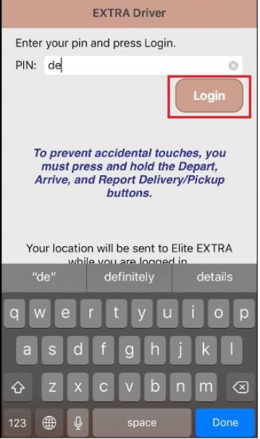
Note: Some drivers may need to input the site name in order to login. To do this, go to “Settings” from the main screen of the app. In the “Elite Extra Site Name” box, they must write “PDX-Mansfield.eliteextra.com” and press save. Then proceed to put their pin in and log in.

- Once the driver’s truck is loaded and the driver is ready to leave, they must press, and hold “Start Route” in the APP.

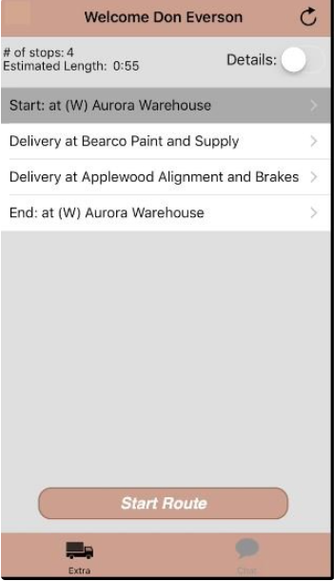

Note: This lets us know that the truck is leaving DT to start the route.

- The driver can toggle the information icon in the upper right corner on the following screen to View Route, access Directions, or Report Delay.
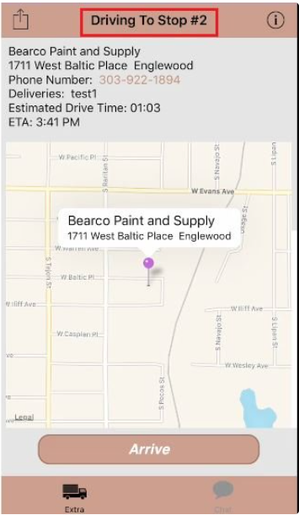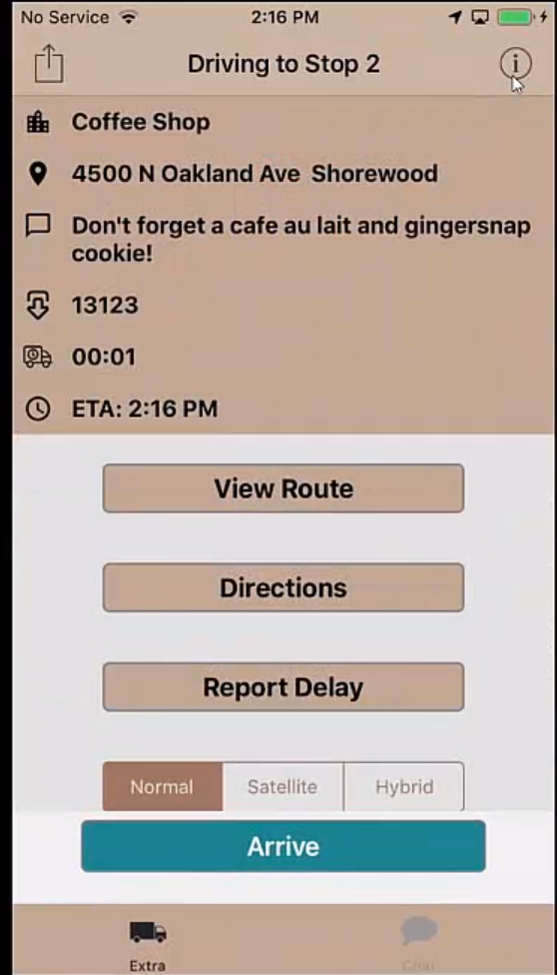
Note: when using the iPhone to obtain directions, one of the following MAPS applications are required to be installed (Apple Maps, Google Maps, WAZE, Smart Truck Route, HERE Maps) in order to utilize this feature.

- When the driver has arrived at the location of their stop, they must press and hold the “Arrive” button.

- When the client has accepted delivery and is ready to sign, the driver should press and hold “Sign for Orders”. This will then bring up a box for the driver to enter the Signers Name by choosing “Select Signer”, enter signers name then have client sign on the screen. Select “Done” on the upper right of the screen to complete the transaction.

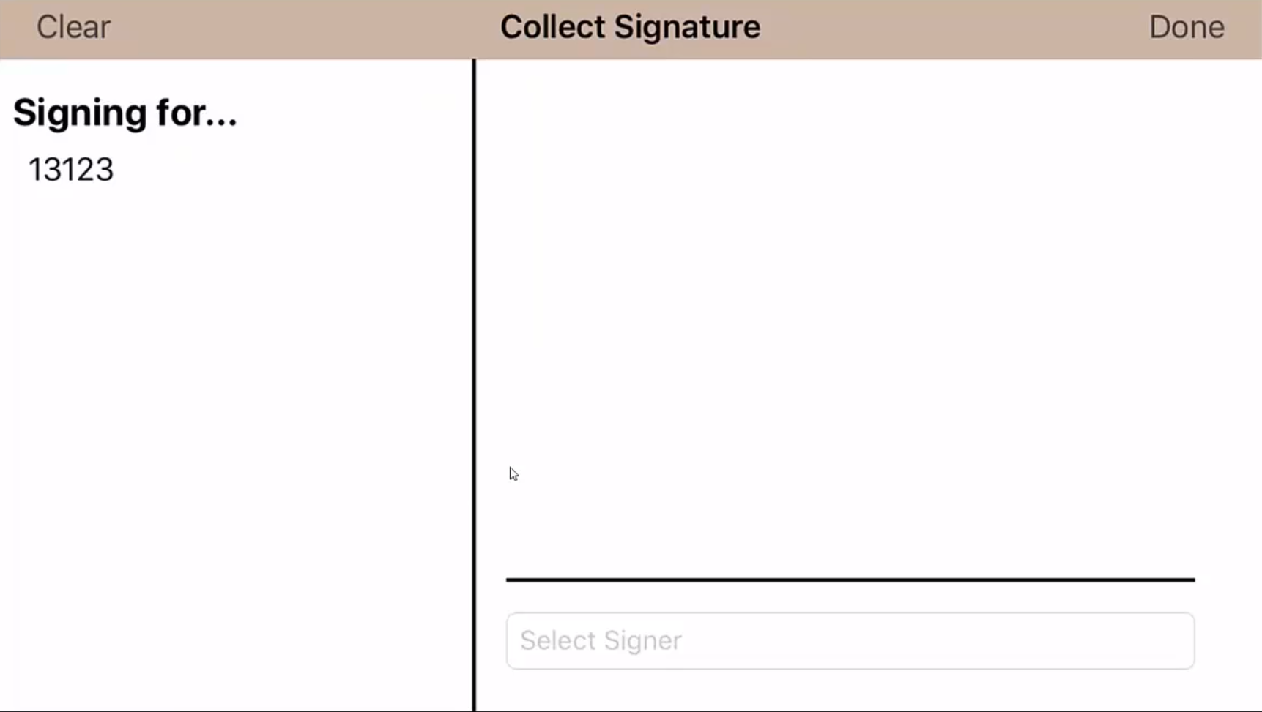

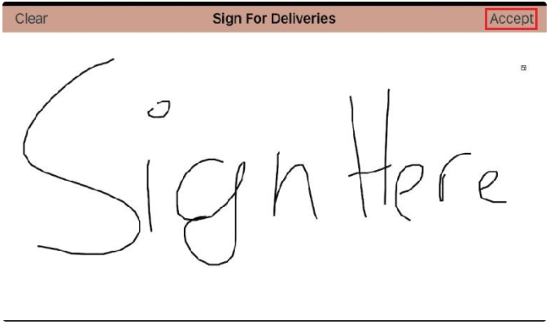

Note: It is especially important for the signer to acknowledge that all pieces of the invoice are accounted for. After they acknowledge this, they can sign.

- When the driver is ready to depart and head towards their next location they will press and hold the “Hold to Complete Stop” button.
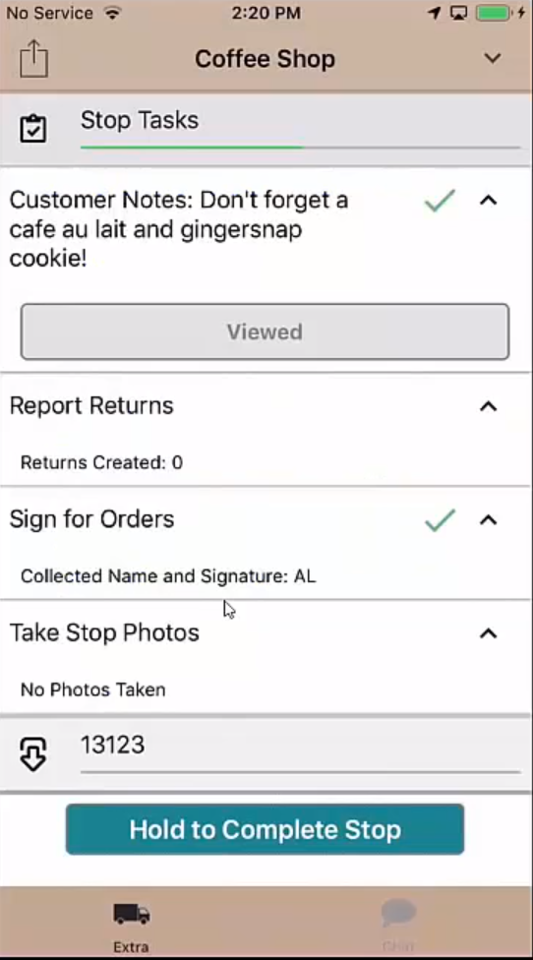

Note: Steps 3-6 will be completed at every stop on the route.
- While completing the route, if there are any delays (traffic, stopping for gas, signer is taking a long time to sign, etc.) the driver is to press and hold the “Report Delay” button. The driver will then select a reason for the delay from the drop-down menu. The driver will then select “15 minutes”, “30 minutes”, or they can enter a custom time in the “Other” box.
Note: It is extremely important to enter all delays that occur during a route. We can see that the driver is stopped because the GPS points will be grouped together. It is within the driver’s best interest to report any and all delays.

- Once the driver is finished the last delivery, they must press and hold the “Depart” button. After finishing the driver will then head back to the designated Hub. After the driver has arrived back at DT and is finished for the day or finished the loop, they are to press and hold the “Finish Route” button
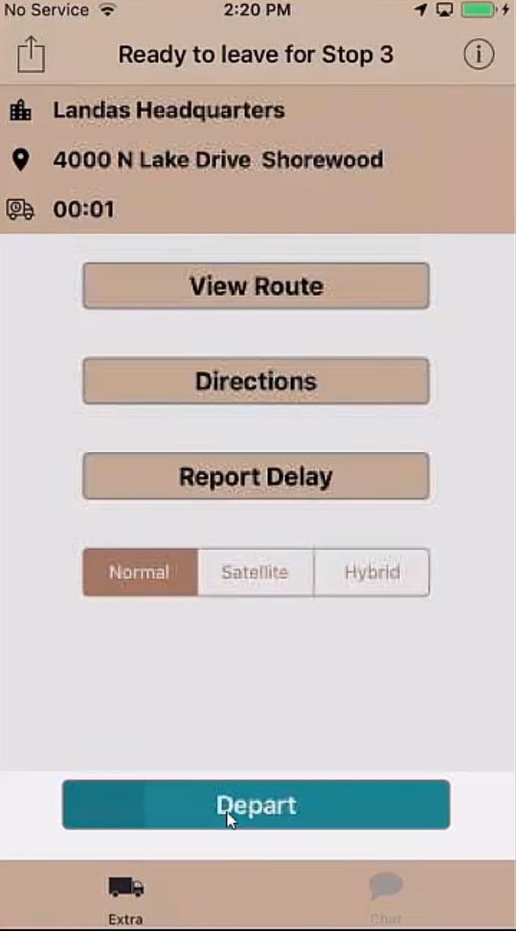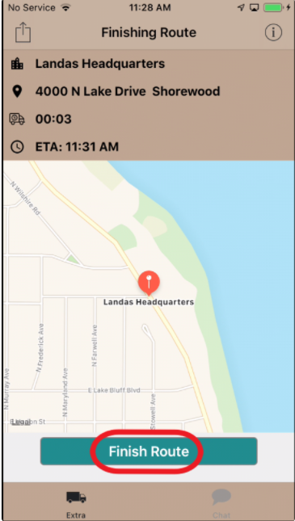

ACKNOWLEDGEMENT:
Using the Elite Extra Application is a mandatory job requirement. All drivers must log in to the application when working.
I have read and been informed about the requirements and expectations of the Elite Extra Application. I understand that if I have questions or concerns, at any time regarding the Elite Extra Application, I will consult with my immediate supervisor.

DRIVER SIGNATURE______________________ DATE:________________
PRINT NAME______________________________

