


KAM User Guide
Key Account Manager



TABLE OF CONTENTS

General Introduction 1
System Summary 2
Key Account Manager (KAM) 2
Overview 2
Prerequisites 2
Roles & Responsibilities 2
Specifications 3
1. Daily Schedule 3
How to Create a Daily Schedule 5
How to Edit or Delete an entry in the Daily Schedule 7
Pending Schedule Dates 8
2. Weekly Off 9
3. Base Roster 11
4. Upload/Download 13
Technical Support 14

General Introduction

This guide will take you through many useful features/functions of the PDX Processing System, to help you get the most out of its vast functionalities.

System Summary

Managed by Account Administrators (AAs) and Key Account Managers, the PDX Processing System is designed to eliminate employee overhead by improving efficiency while providing a flexible, user-friendly system. The PDX Processing System is designed to manage driver scheduling, consolidate client billing, and capture driver settlements.

Key Account Manager (KAM)

Overview
This section highlights the process of the PDX Processing System for Key Account Managers (KAM) and the functionalities available for them.

Prerequisites
- System URL.
- Account Administrator Login ID/Password (Will be provided by the Office Manager/Admin).

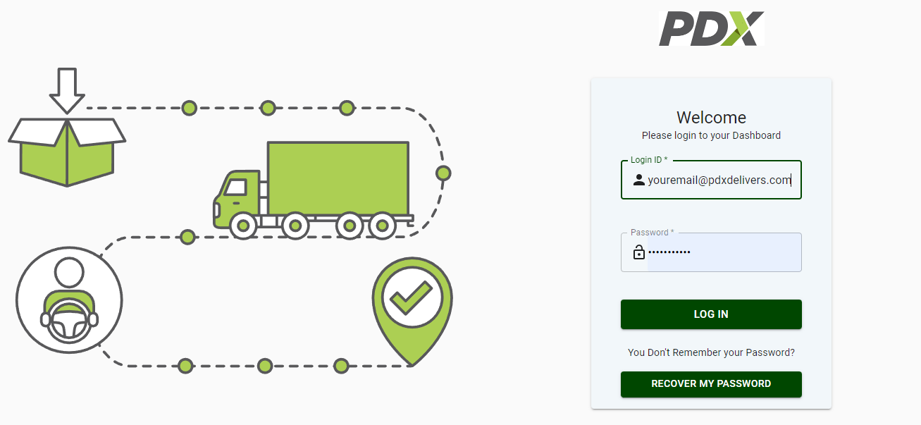
Fig 1. User Login screen

Roles & Responsibilities
A Key Account Manager (KAM) can use the PDX Processing system to perform the following tasks:
- Enter information regarding which independent contractor has provided the services to which customer daily.
- Finalize the daily schedule and submit it to the corresponding Account Administrator.
- Upload/Download Base Roster information
- Submit change requests for pay rate or pay qty to manager for approval
- View current AAA published fuel prices by State

Note: These functionalities are further defined under Specifications.

Specifications

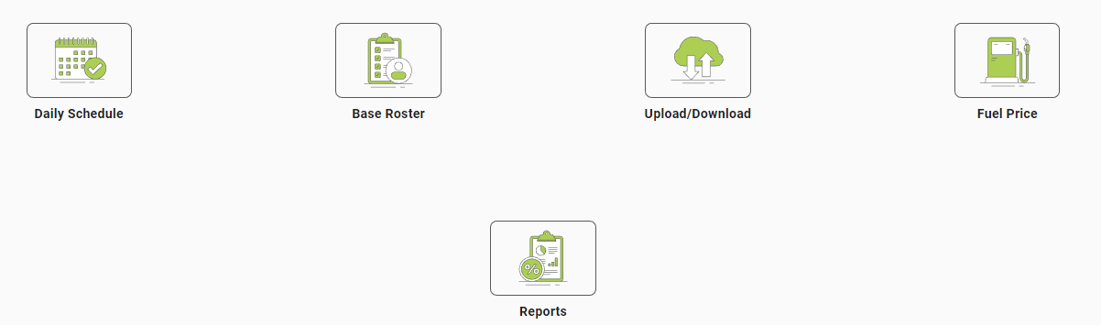

Fig 2. Illustrates the main Functions of the PDX Processing System for Key Account Managers (KAM).

Daily Schedule – input Customer route, IC, pay rate information
  - Base Roster - Predefined list of KAMs customers, routes, ICs, etc.
  - Upload/Download – Used for batch upload/download of Base Roster updates
  - Fuel Price – displays the current fuel prices by state (used to calculate fuel surcharges based on predefined schedules)
  - Reports - This section of the application enables Key Account Managers (KAMs) to run reports on several items.

Daily Schedule
Account Administrators require information on customers, routes, and independent drivers from Key Account Managers (KAMs) for each working day. KAMs enter this information in the PDX Processing System and submit it to Account Administrators for approval and invoice/settlement processing.
Key Account Managers (KAMs) use the Daily Schedule section of this application to copy their daily schedule data from the Base Roster or a previous day’s schedule.

Once the schedule is copied, KAMs can make needed changes to it, like adding new routes, deleting routes, changing independent contractors for specific routes, or changing details related to IC pay rate type, pay rate, etc.

Managers will be notified via email when changes such as pay rate and pay rate type are updated by the KAM for a particular client.

The Daily Schedule screen can be divided into four (5) sections:
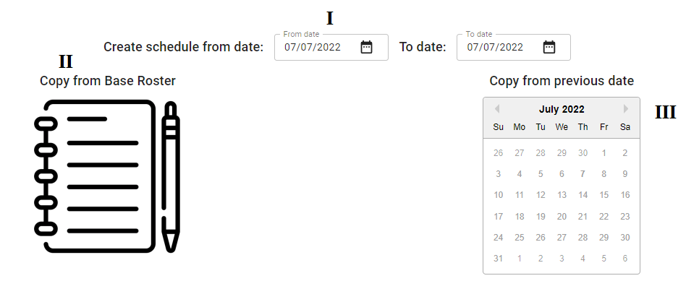
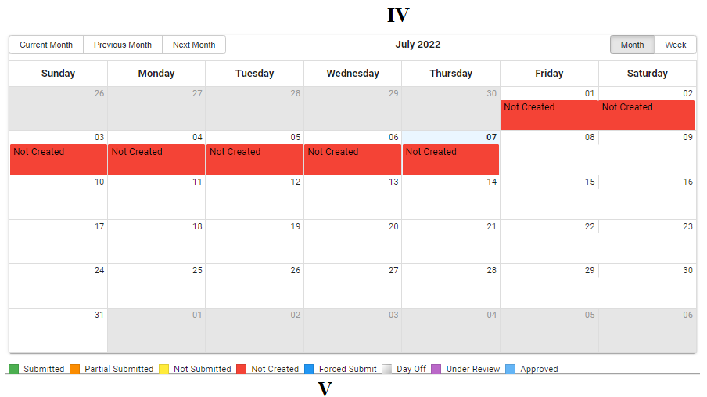
Fig. 3. Daily Schedule
- Create Schedule for Date(S): Used to select the date(s) for which KAM wants to create a daily schedule.
- Copy from Base Roster: Used to create a schedule by copying it from the base roster.
- Copy Your Schedule from Previous Date: Used to create a schedule by copying a previously submitted schedule.
- Schedule Calendar: Highlights the status of a schedule on a selected date through different colors:
- Schedule legend: Shows the KAM a list of colors that apply to their daily schedule to view whether the KAMs schedule has been submitted, partially submitted, not submitted, Under Review, etc.
  - Green: Indicates Submitted, which means the Schedule for that date is completely submitted and has reached the Billing and Settlement stage.
  - Orange: Indicates Partial Submitted, which means the Schedule for that date is partially submitted and only partially submitted data, instead of all records, has reached the Billing and Settlement stage.
  - Yellow: Indicates Not Submitted, which means the Schedule for that date is ready for submission.
  - Red: Indicates Not Created, which means that no schedule exists for the corresponding date.
  - Dark Blue: Indicates Forced Submit, which means that KAMs did not work or were on leave on that particular date, apart from their scheduled off days.
  - White: Indicates KAMs Days Off.
  - Pink: Indicates Transfer. (Coming soon)
  - Purple: Indicates Under Review, which means that there was a change, and it needs to be approved by the assigned manager.
  - Light blue: Indicates your submission to Billing/Settlement has been approved by the Account Administrator and/or your manager.
NOTE: KAM can work on his/her off days, for which they will have to pick a color according to the schedule status, with a Black border on it.

A schedule can be created for any date from the ‘Copy from your previous date’ features of Daily Schedule but for that, the user will need to select only Green color dates (Submitted entries/schedule).

How to Create a Daily Schedule
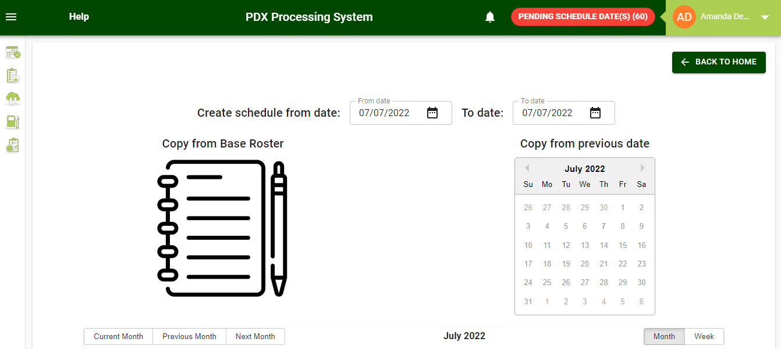
Fig. 4 Create Daily Schedule

- Open the Application URL in the browser.
- Login using the valid Key Account Manager credentials.
- Click on the Daily Schedule tab.
- Select a Date(s) for which you want to create a daily schedule.
- Click on a previously submitted date (highlighted in green) in the “Copy your schedule from the previous date” calendar, if you want to copy a previously submitted schedule.
- Click on "Copy from Base Roster” to copy an entry from the base roster.
- After the data is copied, the following screen will be displayed, where the user will come across four (4) different choices:
  - Add/Edit Schedule for KAM: For reselecting the Date or date range selected earlier in step four (4).
  - Search: For searching Customer and IC.
  - Copy From Base Roster: For re-selecting between “Copy from base roster” and “copy from the previous date”.
  - Entries: Displays all the entries in a tabular form in the grid.

Fig. 5 Update Daily Schedule
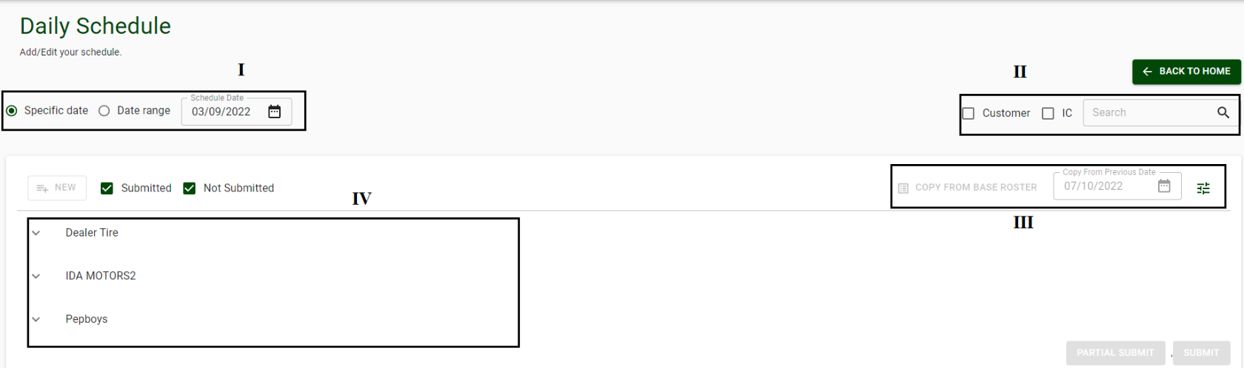
- Click on the New button to enter additional route(s) to Daily Schedule if required.
- Fill in all the necessary details and click on the Create button.
- You will now have two options:
  - Partial Submit: Used to submit only the selected records, leaving the remaining records in the daily schedule list. Users can also add new records until the records are partially submitted.
  - Submit: Used to submit all the entries, which have not been partially submitted. This is the final submission, after which users cannot create a new entry in the daily schedule.

How to Edit or Delete an entry in the Daily Schedule

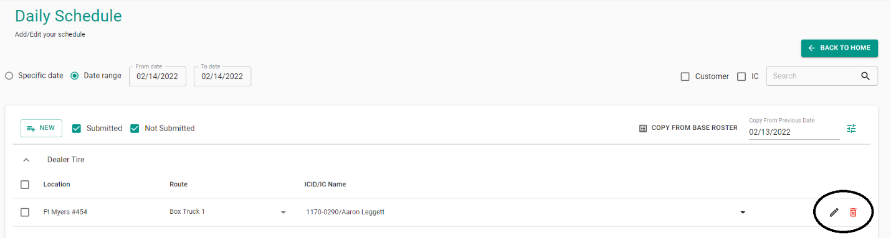
Fig. 6 Edit/Delete Daily Schedule


- Edit Button: Used to edit an existing entry in the grid.

Note: Any changes made by Account Administrators in the ICID/IC Name field of an entry copied from the base roster will be updated and highlighted in yellow. Also, once submitted, the daily schedule cannot be edited by the KAM.

- Editing: In addition to the Edit Button, users can double-click on any field within the line to bring up the Update Entry screen.
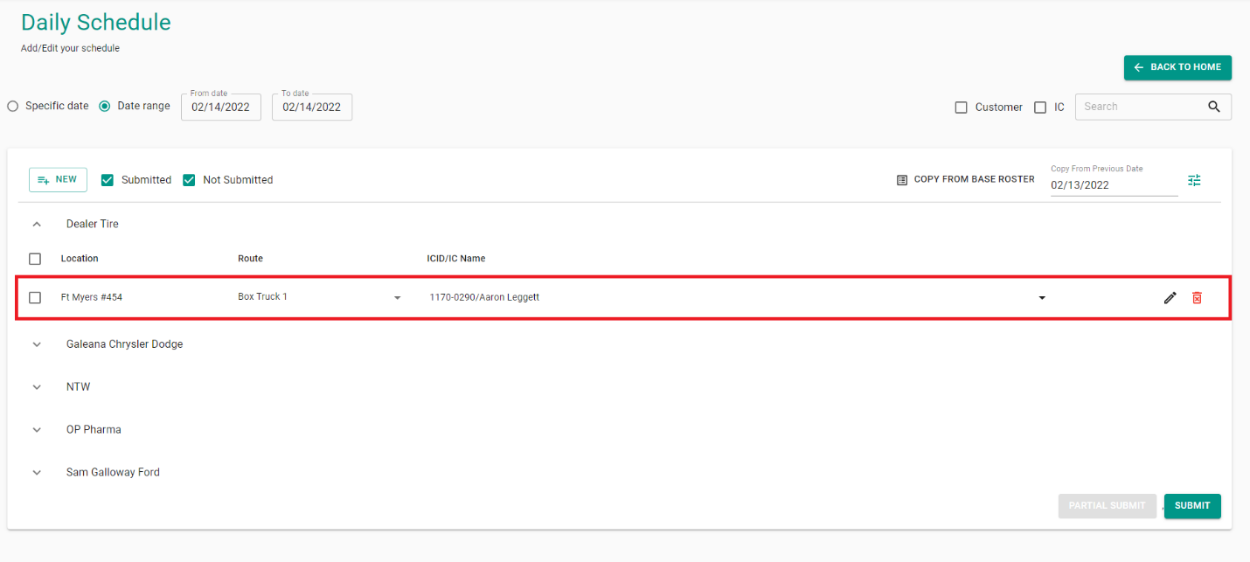
Fig 7. Inline Editing

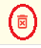
- Delete Button: Used to delete existing entries in the grid.

- Filter Button: This button allows you to filter which column(s) you would like shown on your screen.

Once all the entries are input by the KAM, and either partially submitted or submitted, the information is forwarded to the Account Administrators (AAs), who use this data to approve and create Billing & Settlement records.



Pending Schedule Dates

If a daily schedule for a particular date was not created or was created but not submitted by KAM, then those dates are considered as Pending Schedule Dates.
To access, click on the Pending Schedule Dates button
Pending Schedule Dates are displayed in the form of a list and users can create a schedule for the required pending date by simply clicking on the + icon.

Force Submit
Force Submit simply means that the date for which KAM opted for the Forced Submit option will no longer be displayed in the Pending Schedule Dates List. KAM must choose an option (Holiday, Sick Leave, Bad Weather, etc.) and will be considered as Submitted without any Data.

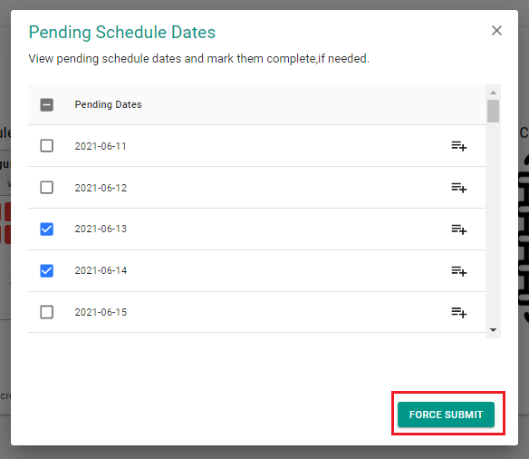

Fig 9. FORCE SUBMIT

NOTE: Force Submit operation can also be performed by Admin/Manager or Account Administrators (AAs) for a particular KAM on any specific Date.

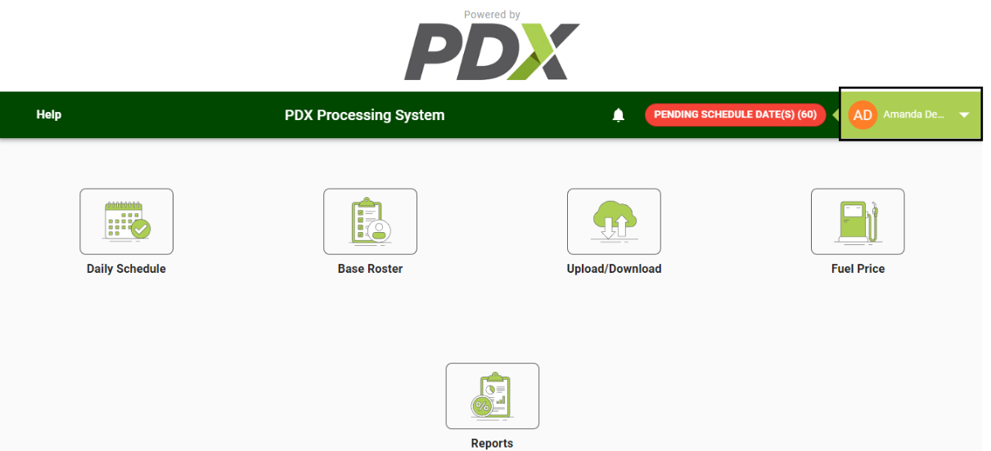
Day Off
Key Account Managers, as well as Account Administrators, Managers, and Admins can mark their off days through the following steps:

- Click on the KAM Name displayed on the top right of the screen.

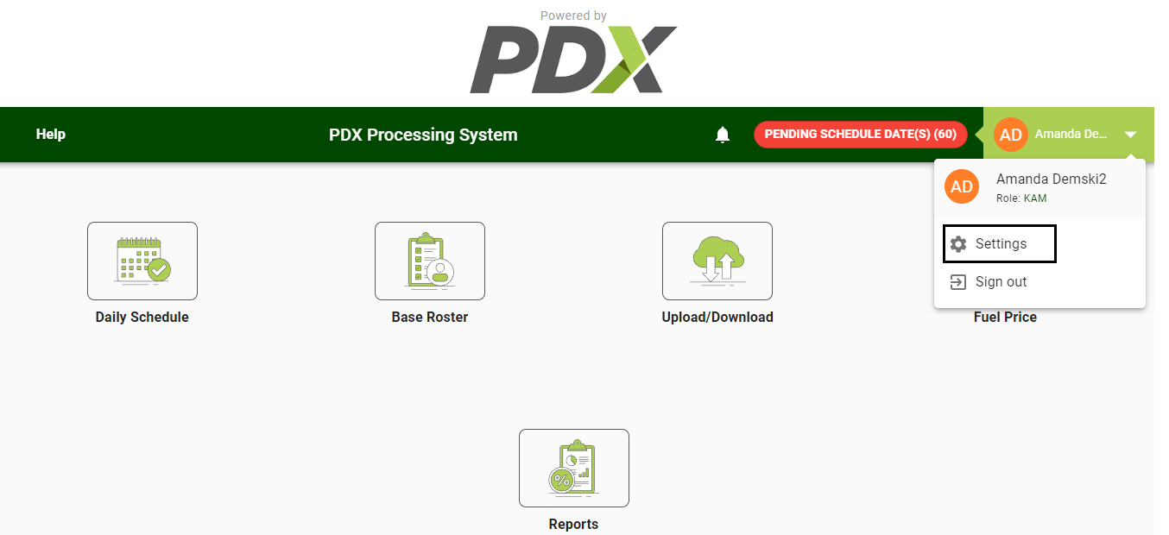
- Click on Settings to open a module with all days listed in it.

- Select the respective off Days

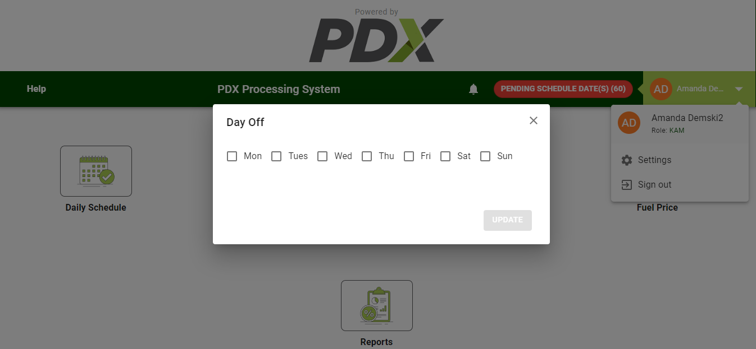

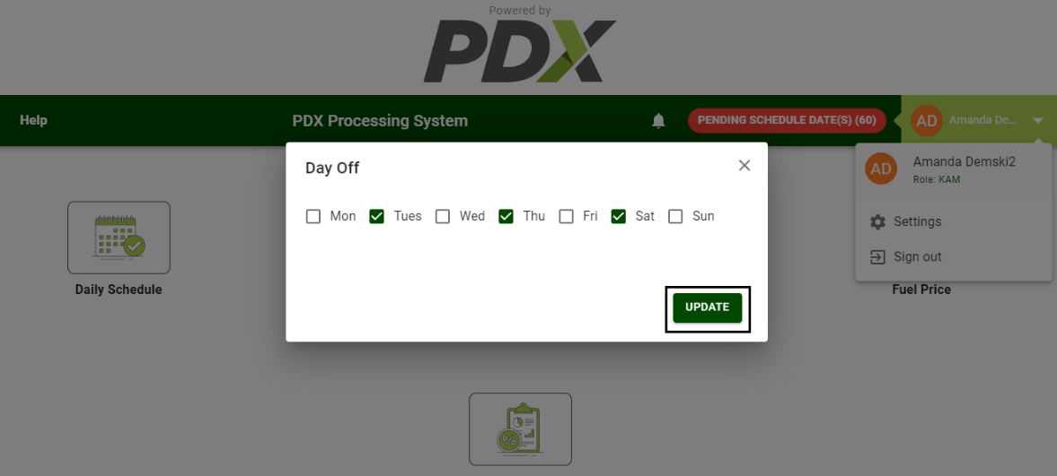
- Click Update.

Base Roster
Base Roster functionality within the PDX Processing System helps create a predefined template of the fixed daily schedule data and store it in PDX Processing System. Key Account Managers use this section of the application to see/change/copy their fixed schedule data (i.e. Customer, Route, Location, Independent Contractor, and Pay rates).

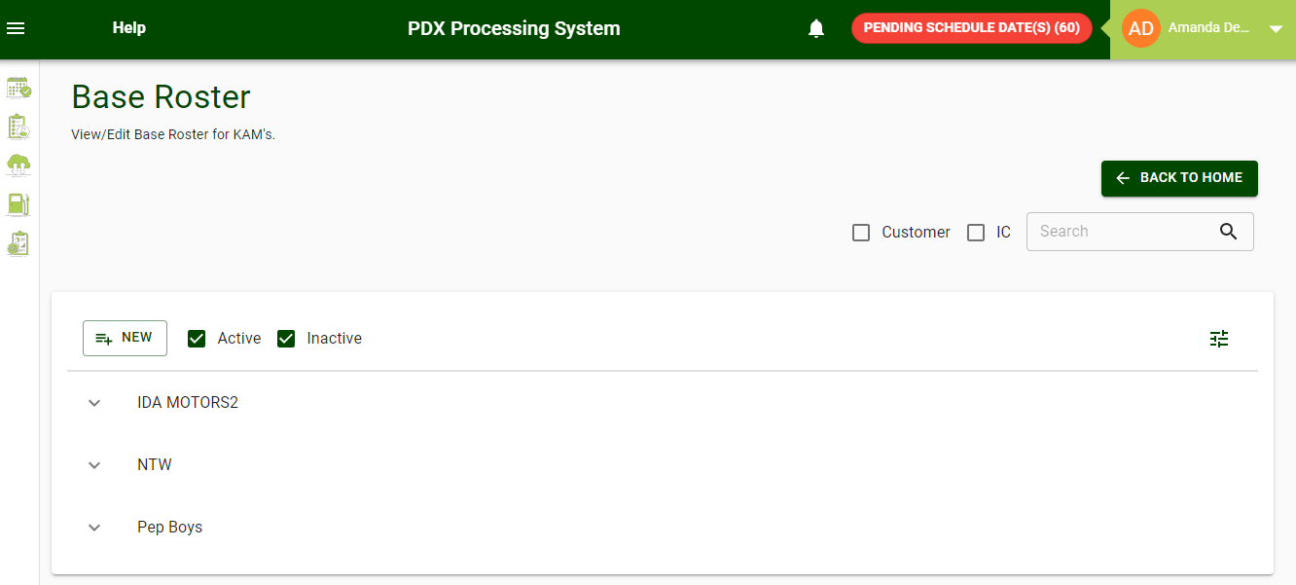
Fig 10. Base Roster Screen

On this screen, Key Account Managers can perform the activities illustrated below:
- Add a New Entry:
  - Click on the New button.
  - Fill in the necessary details.
  - Click on the Create button.
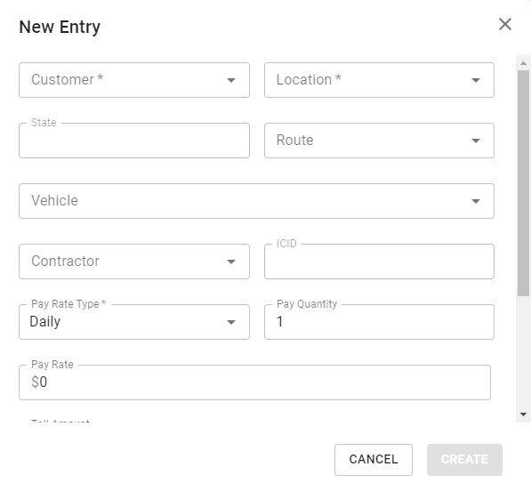

Fig 11. New Entry Screen

- Edit/Delete Existing Entries:
Existing Entries: Used to edit the already existing entries:
- Click on the Pencil Icon.
- Make necessary changes.
- Click Update.

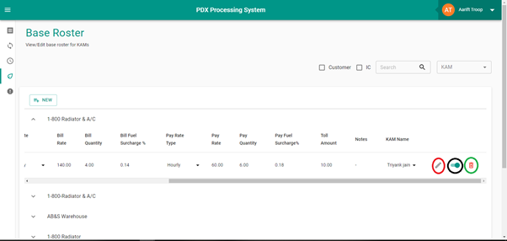Active/Inactive Entries: Toggle button indicates the active/inactive status of the entry in the Base Roster.
- Active Entry: These will be copied when the Key Account Manager (KAM) copies the Base Roster while creating a daily schedule.
- Inactive Entry: Will not be copied when the Key Account Manager (KAM) copies the base roster while creating a daily schedule.

Delete Entries: Account Administrators can delete an entry by clicking on the Trash icon.

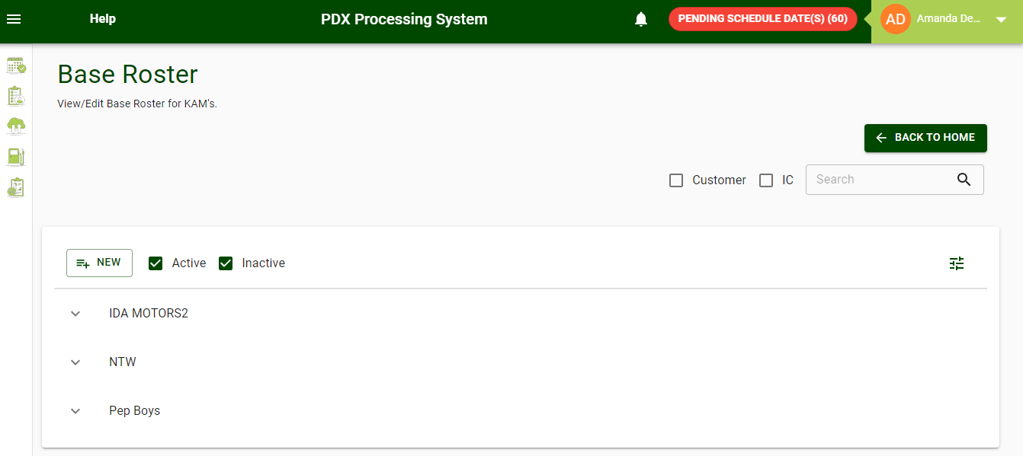
Fig 12. Edit/Activate/Delete option

- Editing:
Key Account Managers (KAMs) can also edit the information within a specific line item by Double-Clicking on any field on that line. This will bring up the Update Entry screen.
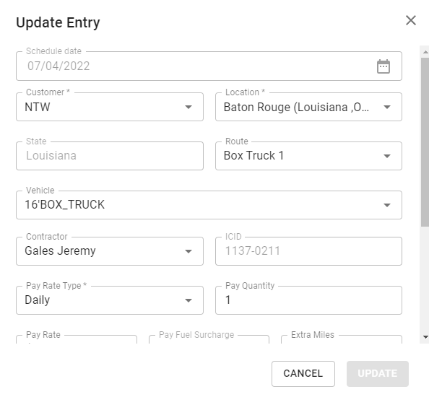
Fig 13. Update Entry
- Search:
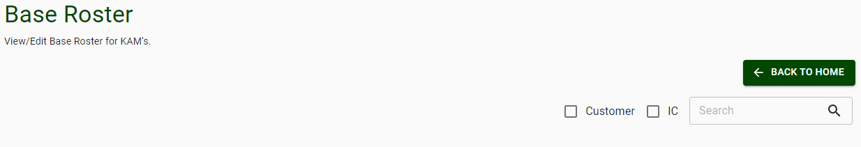

Key Account Managers (KAMs) can use the Search functionality on the Base Roster screen to search an entry according to the requirement by checking one of the boxes- Customer or Independent Contractor (IC).

Upload/Download
This section of the application is used by Key Account Managers (KAMs) to upload/download data in bulk for Base Rosters.
On this screen, Key Account Managers (KAMs) can perform activities illustrated below:
- Download existing/already uploaded Base Roster data as a Zip File (spreadsheet with downloaded Base Roster data) by opting for the option on the screen.
- Download an empty spreadsheet (template) using the Download Template button for Base Roster by selecting the option on the screen. They can fill Base Roster data in it and upload it to the PDX Processing System using the Upload button.
- Key Account Managers (KAMs) can also make changes (add new rows/edit existing rows) to already downloaded Base Roster data in the spreadsheet and upload it again, using the Upload button to reflect changes in the PDX Processing System.

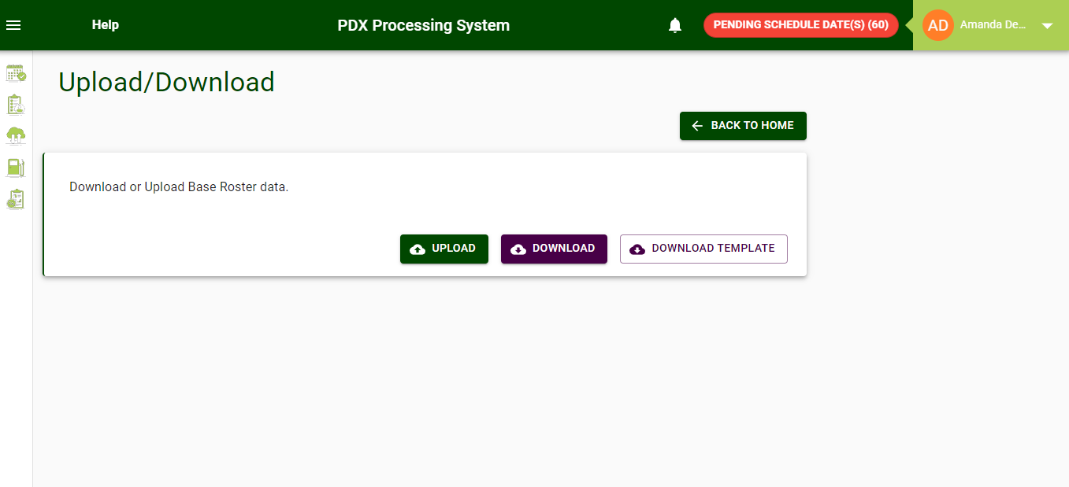
Fig 15. Upload/Download Screen

Fig. 15. Reports Screen

Reports

This section of the application enables Key Account Managers (KAMs) to run reports on several items. The type of reports a Key Account Manager (KAM) can run are listed below:

- Report on specific settlement companies.
- Report on an individual contractor (IC).
- Report on a specific route or location.

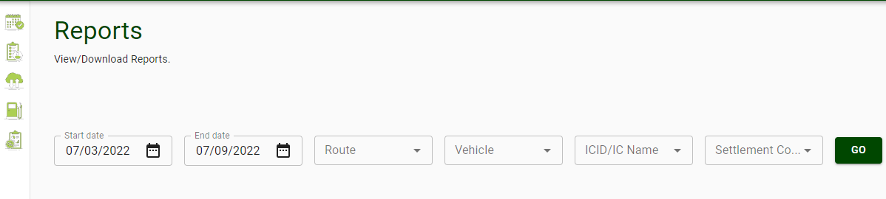
Fig. 15. Reports Screen

- Fuel Price

This section is a reference for KAM’s to view the fuel surcharge schedules. It displays the current fuel prices by state (used to calculate fuel surcharges based on predefined schedules)

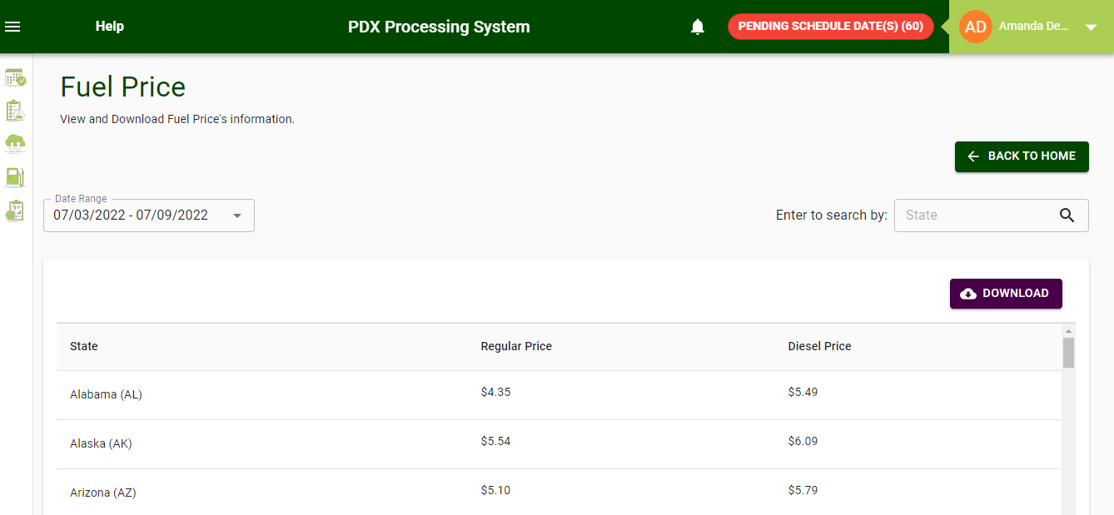

Fig 16. Fuel Price Screen

Daily Schedule Calendar

Summary view by date of current submission status. This provides the KAM with an overview of all dates that have either been submitted, approved, etc. The view can be by week or month. Each day may be selected to view that schedule.

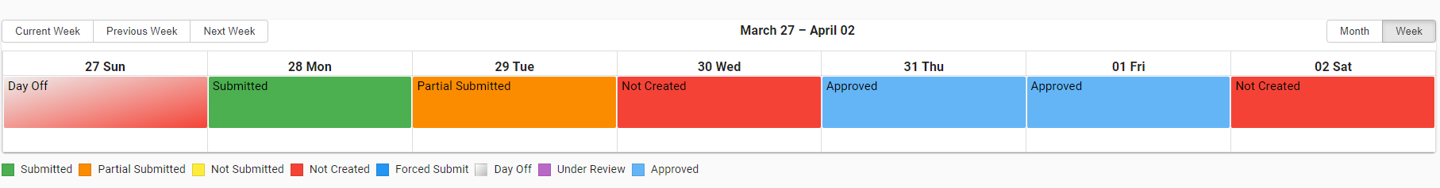

Technical Support
If you require assistance using the PDX Processing System, please email our customer service team at itsupport@pdxdelivers.com Alternatively, call (610) 595-3390.

