
PDX

AA User Guide
Account Administrator


www.pdxdelivers.com

TABLE OF CONTENTS
General Introduction 2
System Summary 2
Account Administrator (AA) 2
Overview 2
Prerequisites 2
Roles & Responsibilities 3
Specifications 4
1. Daily Schedule 5
How to Create a Daily Schedule 6
How to edit or delete a daily schedule 8
2. Billing & Settlement 9
How to add/edit/delete/approve entries in Billing & Settlements 11
3. Upload/Download 14
4. Base Roster 15
5. Reports 18
6. Customers and Independent Contractors (Drivers) 19
7.Lookup 28
8.Billing & Settlement Review 28
9.Fuel Price 29
Further Help 32

General Introduction

This guide will take you through various useful features/functions of the PDX Processing System, to help you get the most out of its vast functionalities.

System Summary
Managed by Account Administrators (AAs) and Key Account Managers, the PDX Processing System is designed to eliminate employee overhead by improving efficiency while providing a flexible, user-friendly system. The PDX Processing System is designed to manage driver scheduling, consolidate client billing, and capture driver settlements.

Account Administrator (AA)

Overview
This section highlights the process of the PDX Processing System for Account Administrators (AAs) and the functionalities available for them.

Prerequisites
- System URL.
- Account Administrator Login ID/Password (Will be provided by the Office Manager/Admin) (Fig. 1)

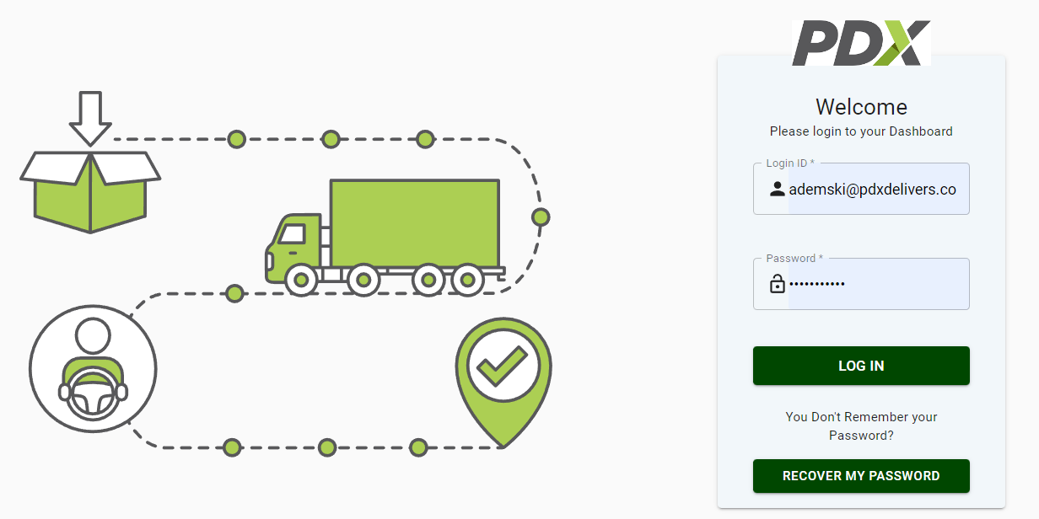
Fig 1. User login screen

Roles & Responsibilities
An Account Administrator (AA) can use the PDX Processing system to:
- Review, correct, and approve billing /settlement details submitted by Key Account Managers (KAM) daily.
- Upload new customers and independent contractors into the system.
- View and export billing and settlement report data for specific dates.
- Upload, add or change base rosters for KAMs.
- View, create, and submit daily schedules on behalf of the KAMs.

Note: These functionalities are further defined under specifications.

Specifications

Home Screen
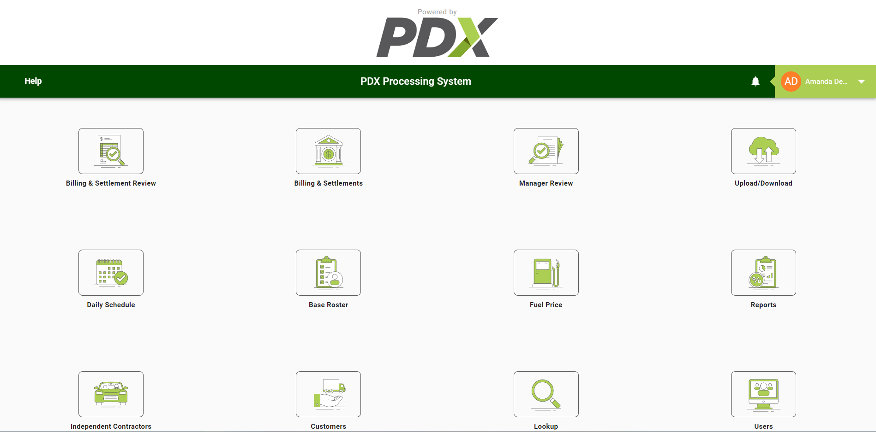
Fig 1a. PDX Processing System offers various functionalities for Account Administrators.

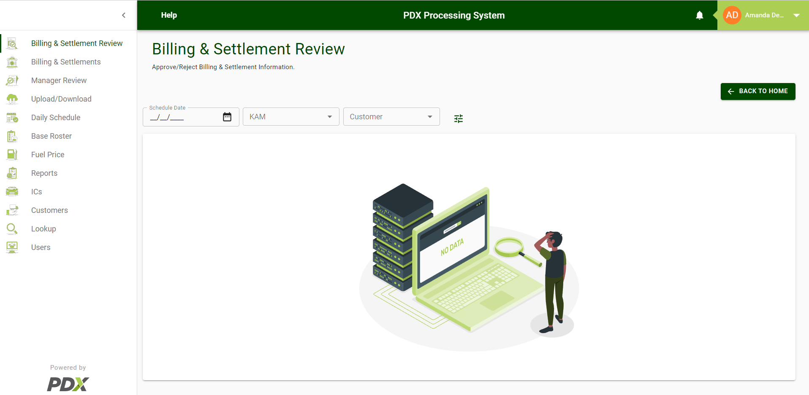Fig 2. Illustrates the main functionalities of the PDX Processing System for Account Administrators (AA).

Daily Schedule
The daily schedule functionality of PDX Processing System is used to copy or add to the daily schedule data. The schedule will contain information about customers, routes, independent contractors, and more. The schedule can be copied from the base roster, or from a previous day’s schedule, by the Key Account Managers (KAM); which is then submitted to the Account Administrator.
Account Administrators can create daily schedules and submit it on behalf of Key Account Managers (KAM), using the same Daily Schedule functionality.

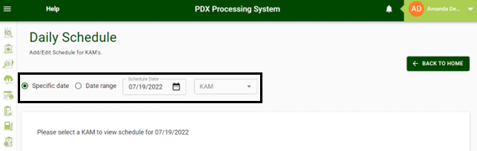
Fig 3: Illustrates the daily schedule screen

- The above image shows the search feature within the daily schedule screen. In this section AA can search by KAM(S) for a specific date or date range.

How to Create a Daily Schedule
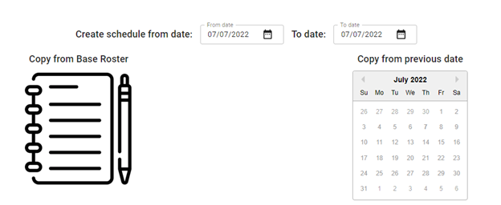
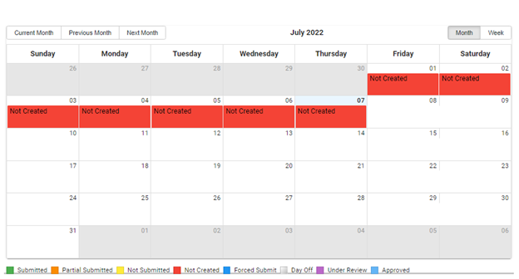
Fig 4: Illustrates the create schedule screen

- Open the Application URL in the browser.
- Login using the valid Account Administrator credentials.
- Click on the Daily Schedule tab.
- Select a Date and KAM name for which you want to create a daily schedule.
- If you want to copy a previously submitted schedule, click on a previously submitted date (highlighted in green) in the “Copy your schedule from previous date” calendar.
- Click on "Copy from Base Roster” to copy an entry from the base roster.
- After the data is copied, the following screen will be displayed (fig.5), where the user will come across four different choices:
  - Add/Edit Schedule for KAM: For reselecting Date & KAM Name selected by the user in step four (4).
  - Search: For searching Customer and IC.
  - Copy From Base Roster: For re-selecting between “Copy from base roster” and “Copy from previous date.”
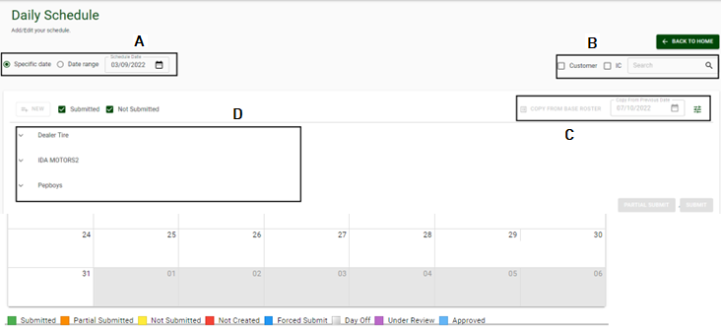
  - Entries: Displays all the entries in a tabular form in the grid.

Fig. 5. Edit daily schedule screen

- Click on the New button.
- Fill in the necessary details and click the Create button.

- You will now have two options:

  - Partial Submit: Used to submit only the selected records, leaving the remaining records in the daily schedule list. Users may continue entering new records until all records are partially submitted.
  - Submit: Used to submit the entries, which have not been partially submitted. This is the final submission. After which users cannot create a new entry in the daily schedule.
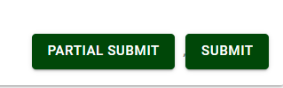

How to edit or delete a daily schedule
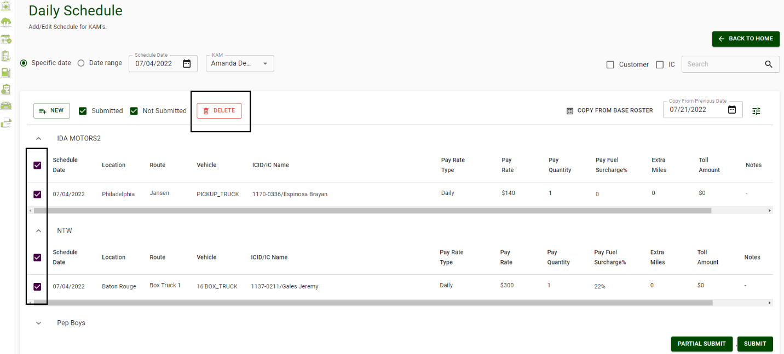
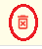
Fig. 6 Edit/Delete functionality
Delete Button: Used to delete existing entries in the grid.

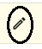
Edit button: Used to edit an existing entry in the grid.

Note: Any changes made by Account Administrators in the ICID/IC name field of an entry copied from the base roster, will be updated, and highlighted in yellow.

Inline editing: Apart from using the edit button, users can use inline editing to edit a specific column by double clicking within the line item. Note that changes to certain columns will require the user to review other parameters that may be affected by the changes. (I.E., changing the bill rate type from hourly to daily will require the user to review the bill rate and bill quantity fields.)

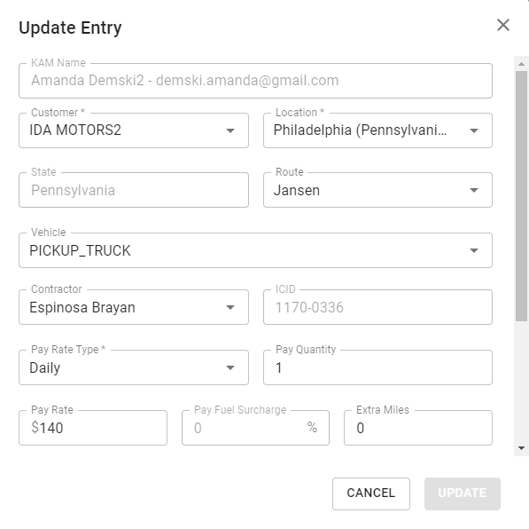
Fig. 7 Update Entry screen

Billing & Settlement
This section includes detailed information of customer billing and driver settlements, provided by Key Account Managers submissions. This section also provides information on individual routes. Including customer location, independent contractors, billing, settlements, profit percentage, etc.
Once completed, the data will be reviewed and marked ‘approved’ by the Account Administrators. The approved data is later used to generate billing and/or settlement reports.
Account Administrators can use this functionality to view billing and settlement details for a specific date or a date range.
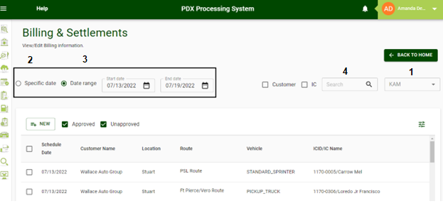

Fig 8. Illustrates Billing & Settlements Screen

Account Administrators (AAs) can use this functionality of the application to perform the following tasks:
- View the billing and settlement information submitted by different KAMs.
- View the billing and settlement information for different dates.
- Analyze the billing and settlement data for a specific date or date range.
- Search the billing and settlement data for a specific customer or IC.

How to add/edit/delete/approve entries in Billing & Settlements
- Add New Entry:
  - Click on the New button.
  - Input the customer/route information (NOTE: Field marked by asterisks are required.)
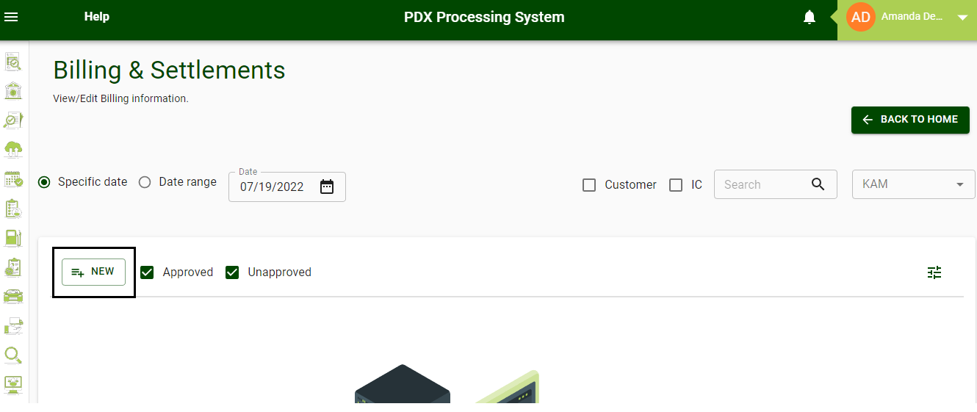
  - Click the CREATE button to complete the entry.

Fig 9. Billing and Settlements create new entry screen
- Edit the existing entries:
Edit Button: Edit the existing entries and records by following the steps below:
- Click on the Pencil icon to open the edit module.
- Make the necessary changes.
- Click the Update button.
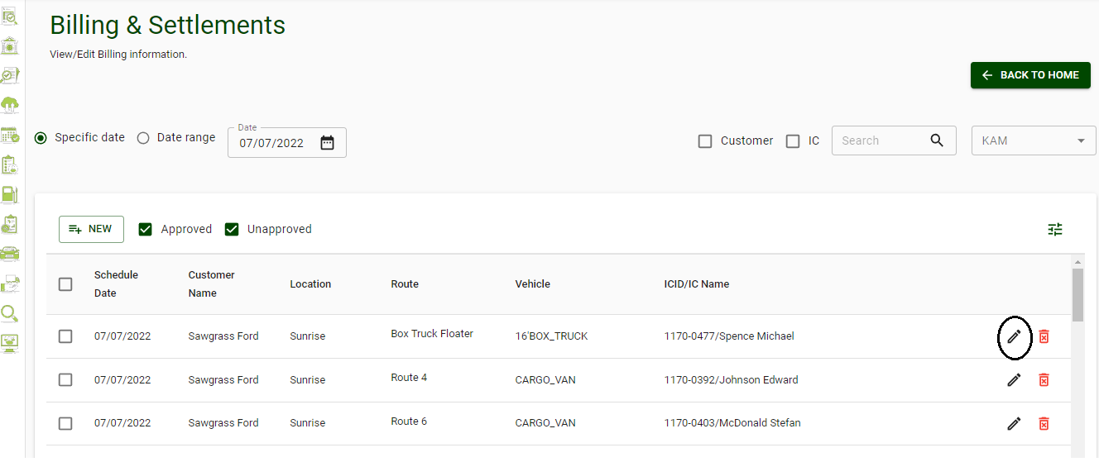
Fig 10. Billing and settlements date range option
Fig. 6 Edit/Delete functionality
Delete Button: Used to delete existing entries in the grid.

Edit button: Used to edit an existing entry in the grid.

- Delete single or multiple entries:
Single entry: Click on the highlighted icon circled in green to delete an entry.
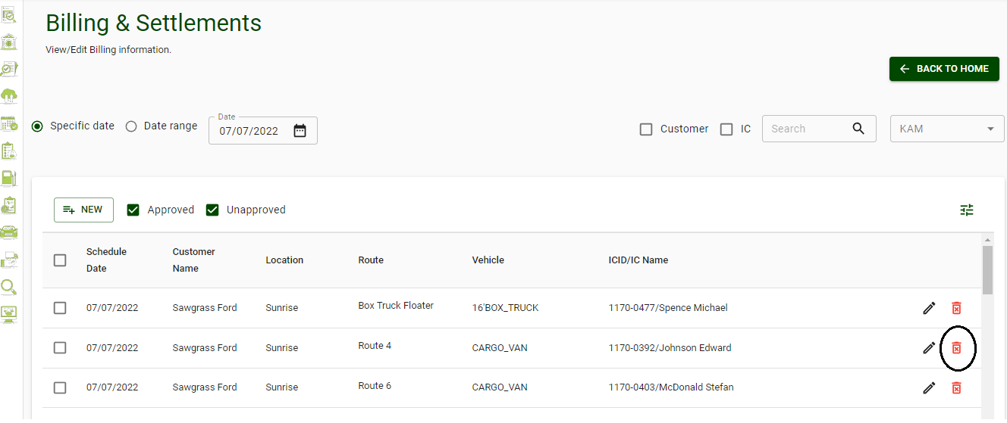
Fig 11. Billing and Settlements edit/delete function
Multiple entries:
- Select the entries that need to be deleted.
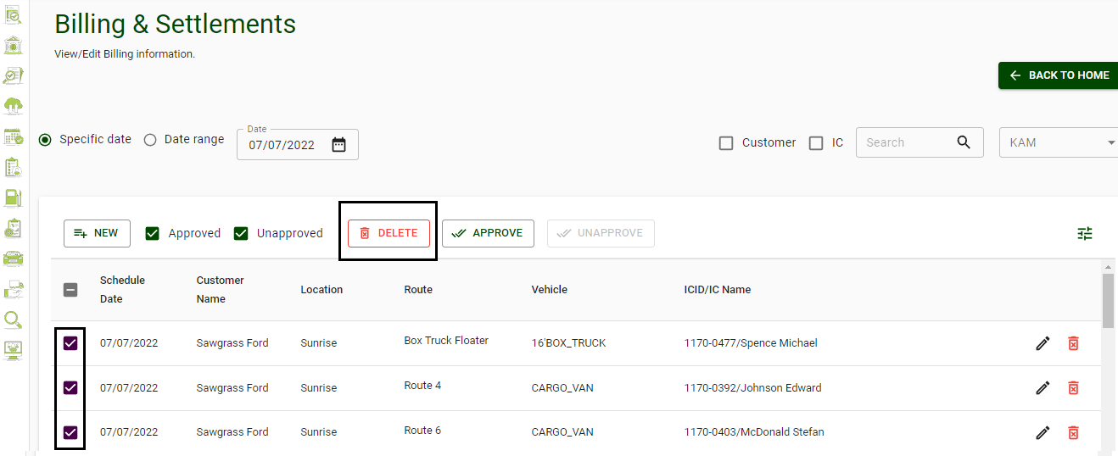
- Click Delete.

Fig 12. Billing and settlements multiple entry function
- Approve existing entries:
Account Administrators can give their final approval to the reviewed entries by:
- Selecting entries that require approval.
- Clicking on the Approve button.
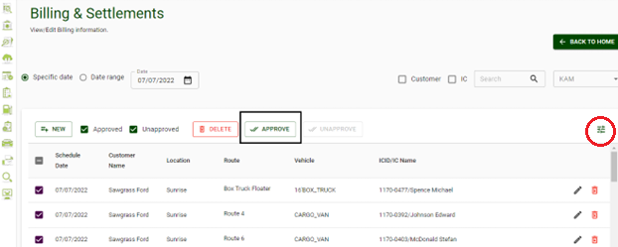
Fig 13. Billing and Settlements approval screen
- Customizing the view:
Account Administrators (AAs) can customize the billing/settlement screen to filter which columns to show/hide by clicking on the filter icon (circled in red in the above image).
  - Customer: When selected, it displays all the customer-related information, like customer name, location, route, etc.
  - IC: Displays all the IC-related information, like IC name, IC ID, settlement company, etc. when selected by AAs.
  - Billing: Displays all the billing-related information like billing rate, billing amount, etc.
  - Settlement: Displays all the settlement-related information, like pay rate, pay quantity, etc.

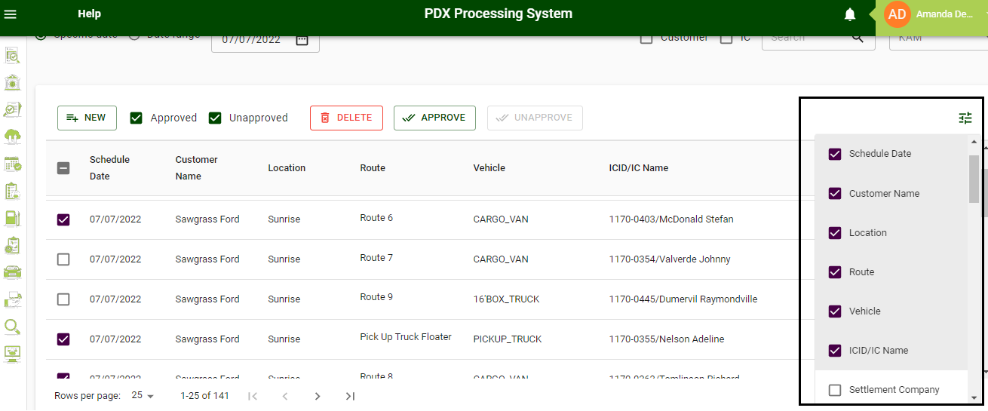
Fig 14. Billing and settlements filter options

Upload/Download
This section of the application is used to upload/download data in bulk for customers, independent contractors, and base rosters. Account Administrators can use this section of the application to do the following:
- Download: Existing customers, independent contractors, and/or base roster data as a Zip File (spreadsheet with downloaded data for selected options) by choosing the corresponding option on the screen.
- Download Template: Use the Download Template button for customers, independent contractors, and/or base roster by selecting the corresponding option from the screen.
- Upload: Add new customers, ICs, and Base Roster data utilizing the specific Download Template for each one. Select upload, choose the correct file, and click UPLOAD.
3A. Make changes (add new rows/edit existing rows) to already downloaded customers, independent contractors, and/or base roster data in the spreadsheet, and upload it again using the Upload button to reflect changes in the system.
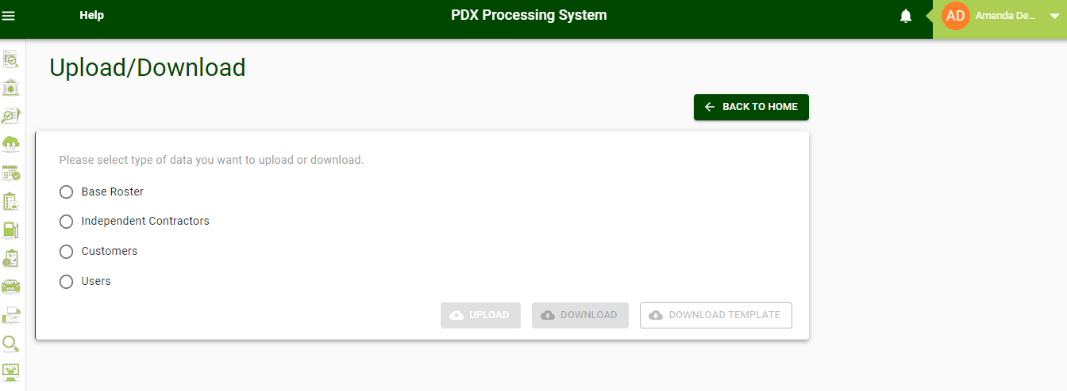
Fig 15. Illustrates the Upload/Download screen

Base Roster
Base Roster functionality creates a predefined template of the fixed daily schedule and stores it in PDX Processing System for each KAM.
Account Administrators can use the same Base Roster screen (fig.17.) to access base roster data at the customer level or by choosing one or more KAMs to view/change/add or make changes.
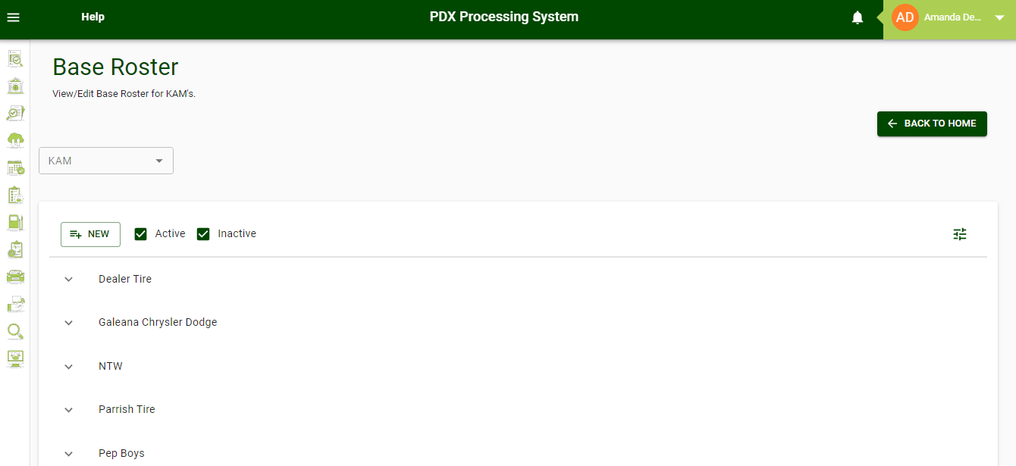
Fig 16. Illustrates the Base Roster Screen
On this screen, Account Administrators can also perform activities illustrated below:

- Add a New Entry:
  - Click on the New button.
  - Fill in all the necessary fields.
  - Click on the Create button.
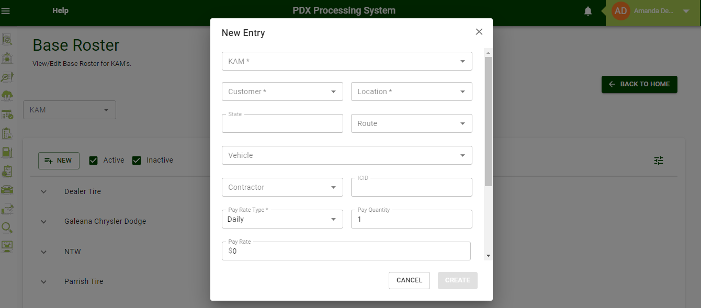
Fig 17. Illustrates the new entry screen

- Edit/delete existing entries:
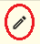Existing entries: Used to edit the already existing entries:
- Click on the Pencil Icon or double-click on the line item.
- Make necessary changes.
- Click Update.
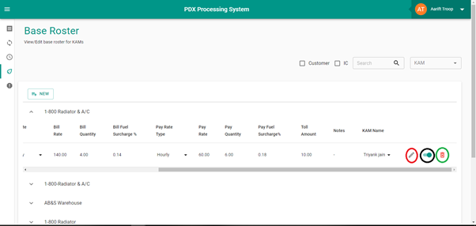Active/inactive entries: This toggle button indicates the active/inactive status of the entry in the base roster.
- Active Entry: Active entries will be uploaded to a KAMs daily schedule from the base roster when the Account Administrator copies the base roster while creating a daily schedule.
- Inactive Entry: Inactive entries will not be copied when the Account Administrator copies the base roster while creating a daily schedule

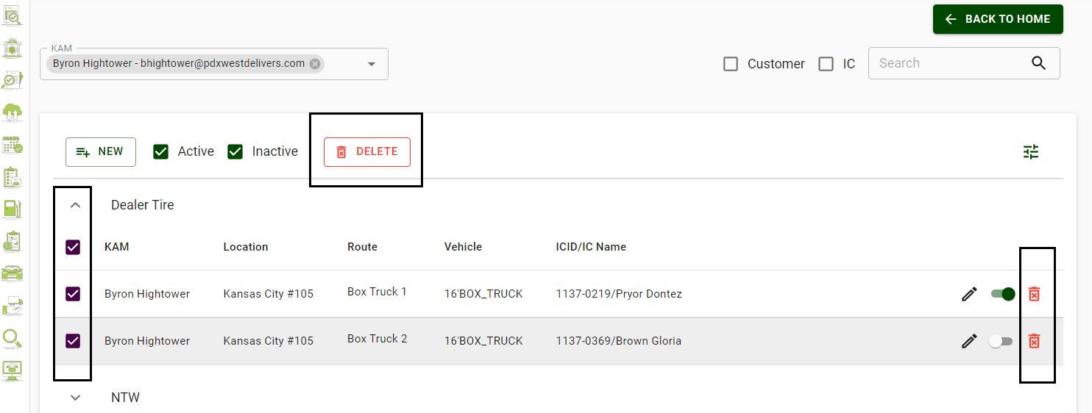
Delete Entries: Account Administrators can delete an entry by clicking on the trash icon or selecting the line item(s) to be deleted and clicking on the DELETE button at the top of the page
Fig 18. Illustrates the Base Roster toggle Screen

Reports
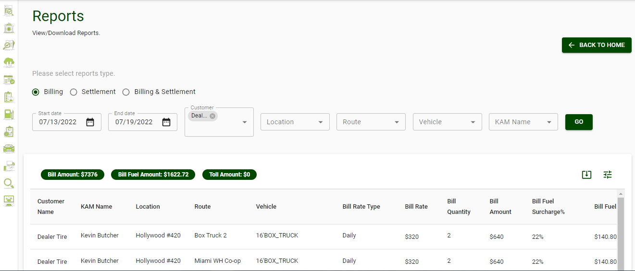
The reports screen allows Account Administrators to view/download a report based on selected parameters: billing, settlement, billing & settlements.
Fig. 19. Edit/Delete functionality

Billing: Displays the relevant information related to billing for the selected timeframe in the form of a report.
STEPS:
  - Select the Billing button.
  - Select the Date range.
  - Choose the desired parameters (Customer, Location, Route, Vehicle, KAM(S).
  - To download the report, click on the Export button.
Note: Leave blank to select all.

- Settlement: Displays all the relevant information related to settlement for the selected time in the form of a report.
STEPS:
  - Select the Settlement button.
  - Select the Date range.
  - Choose the desired settlement parameters (Route(s), Vehicle(s), KAM(s), ICID(s), Settlement Co., etc.)
  - To download the report, click on the Export button.
- Billing & Settlement: Displays all the relevant information related to billing and settlements for the selected time in the form of a report.
STEPS:
  - Select the Billing & Settlement button.
  - Select the Date range.
  - Choose the desired parameters as above (leave blank to select all)
  - To download the report, click on the Export button.

Customers and Independent Contractors (Drivers)
Account Administrators can create, update, search, activate, and inactivate an IC record using the independent contractor screen.
Account Administrators can also create a new record of a customer using the customer functionality of the PDX Processing System.

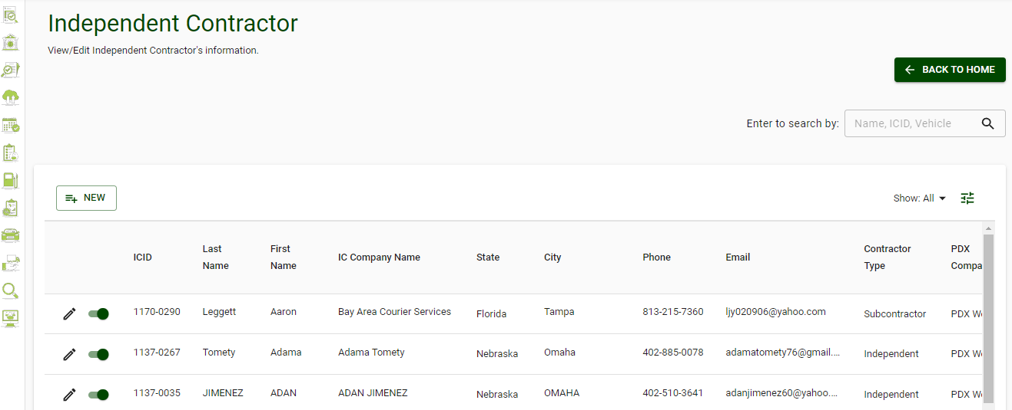
- Independent Contractor
Fig 20. Illustrates the customers and Independent Contractor (IC) Screen

On an Independent Contractor screen, an AA can perform the following operations:
- Create a new Independent Contractor (IC) record with necessary details by:
  - Click on the New button.
  - Fill in all the necessary fields.
  - Click on the Create button.
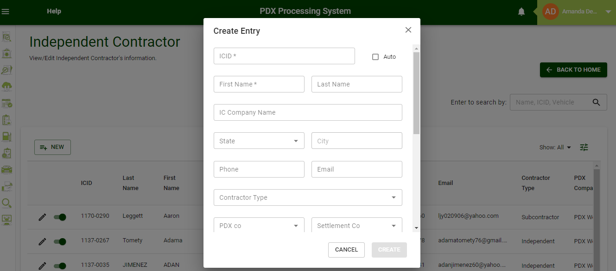
Fig 21. Illustrates the Create Entry Screen

- Update the existing Independent Contractor (IC) Record: Account Administrators can update an existing IC record by:
  - Clicking on the edit button in front of any record or double-click on the line item itself.
  - Updating the required fields.
  - Click the Update button.
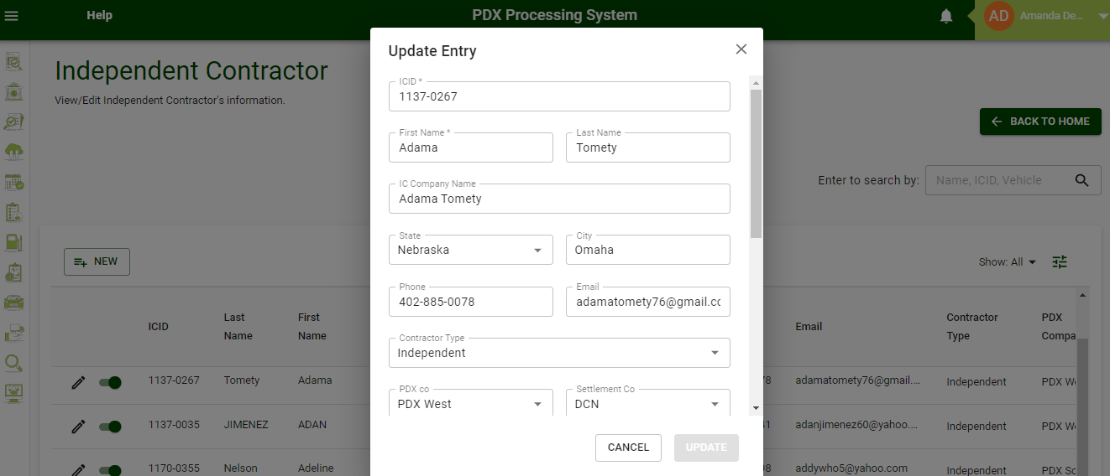
Fig 22. Illustrates the Update Entry screen

- Mark an existing IC Record as Active or Inactive: If an IC is no longer working for PDX, Account Administrators can mark any IC record inactive by using the toggle button present in front of every record.

NOTE: An IC cannot be deactivated if they are present in an existing Base Roster.
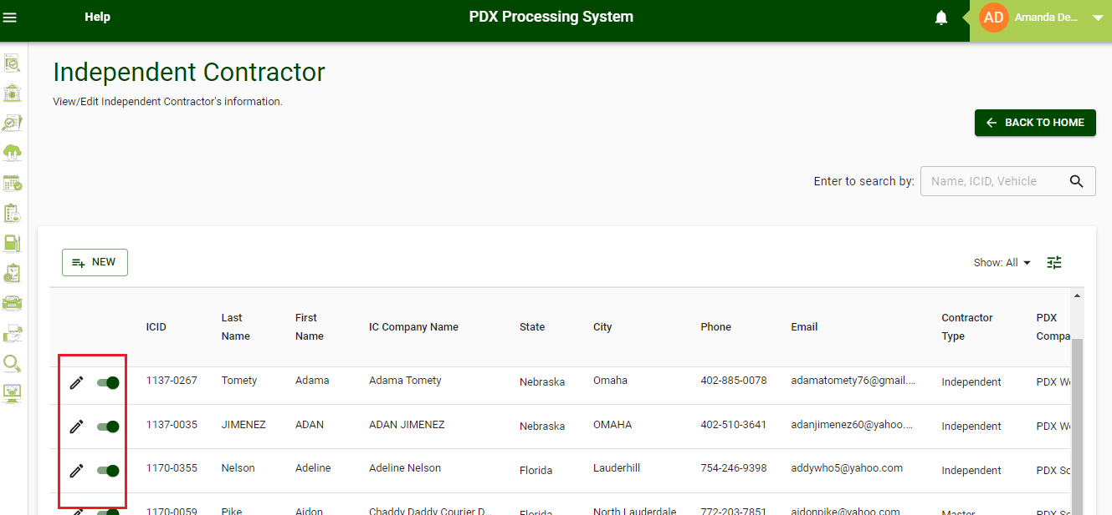

Fig 23. Illustrates the IC active/inactive Toggle function
NOTE: The record of an IC marked inactive will not be visible while creating a new record in the Base Roster and/or Daily Schedule.

- Search a specific IC record:
Account Administrators can use the IC screen to search a particular IC record by entering the name, ICID, or vehicle of the required IC in the search field. Once entered, it will display all the matching records in the grid.

- View IC records according to their Active/Inactive Status: To view records of only active or only inactive IC:
  - Click on the Drop-Down Menu on the top right side of the grid.
  - Select one of the three options:
  - Only Active: If selected, display only the active ICs in the grid.
  - Only Inactive: If selected, display only the inactive ICs in the grid.
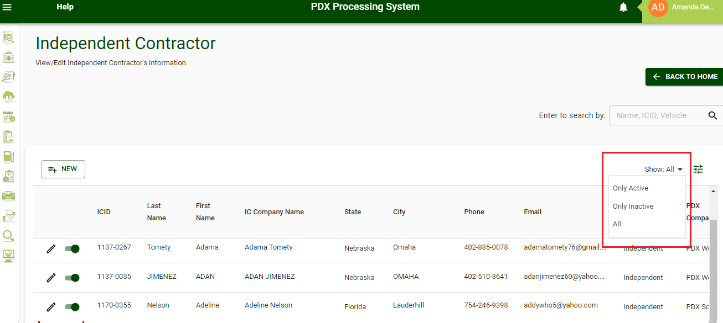
All: If selected, it displays both the active and inactive ICs in the grid.

Fig 24. Illustrates the IC active/inactive filter option

- Customers:
On the Customers Screen, an Account Administrator can perform the following operations:
- Create a record for a new customer:
Account Administrators can create a record for new customers, and their corresponding branches for various locations, as well as different routes for various locations.
  - Create a New Customer
    - Click on the Customer button on the customer screen.
    - Fill in the Customer Name & Industry Type.
    - Click on Create button.
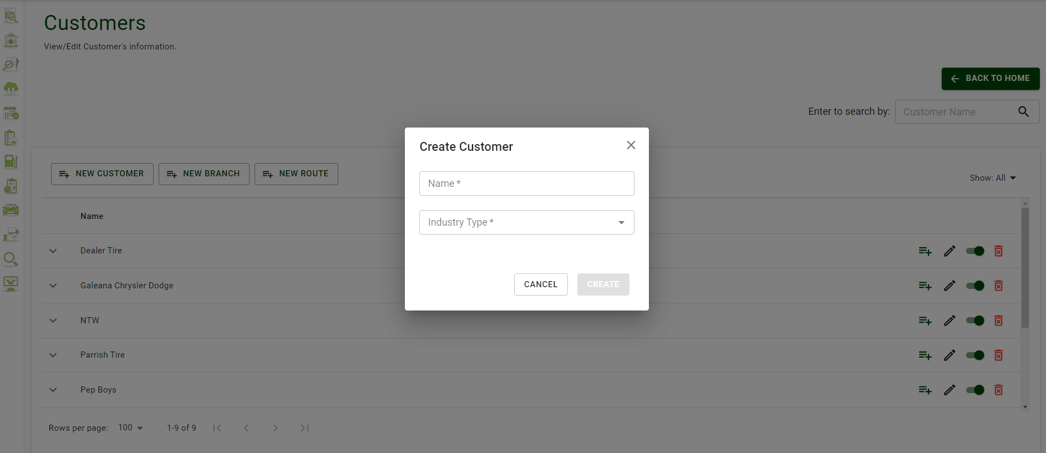
Fig 25. Illustrates the Create Customer function

  - Create a New Branch:
    - Click on NEW BRANCH to view Create Branch screen.
    - Complete the required information.
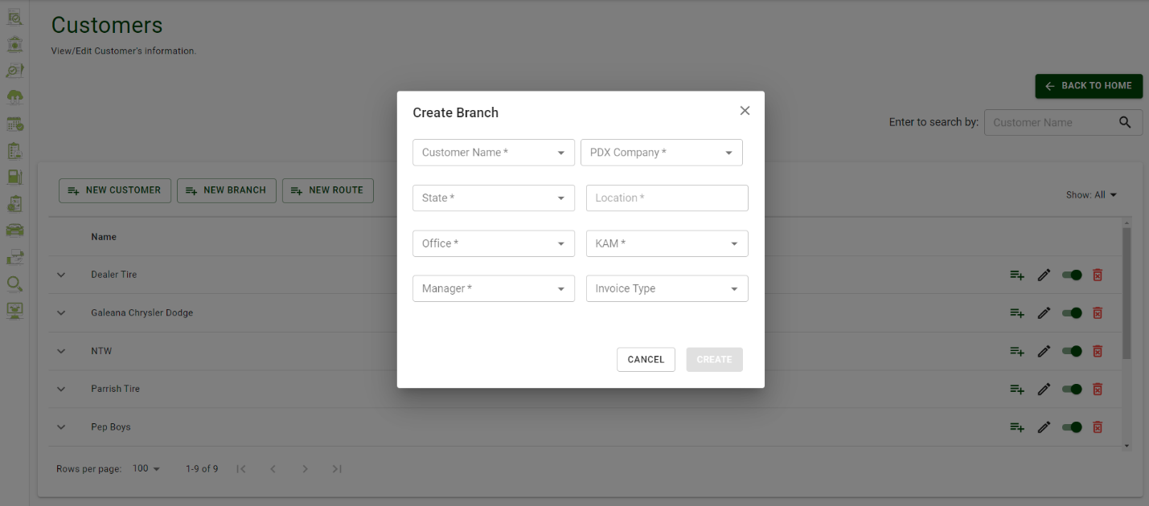
    - Click on the Create button.
Fig 26. Illustrates the Create Branch screen

  - Create a New Route
    - Click on Create Route button to view Create Route box.
    - Fill in the required information of the New Route.
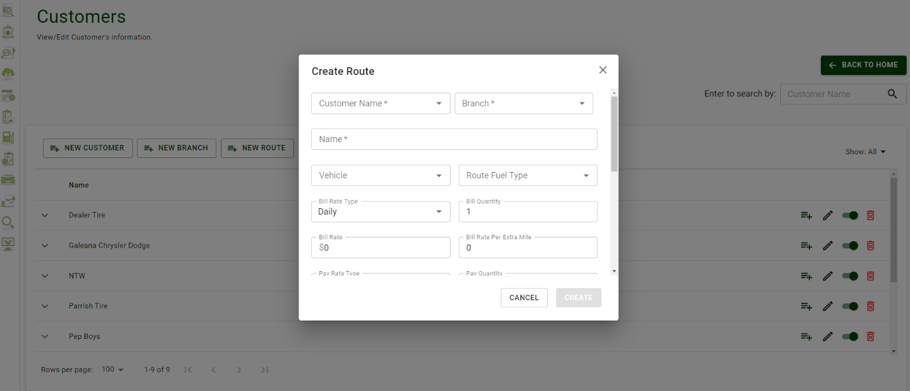
    - Click on the Create button.

Fig 27. Illustrates the Delete Route function

- Edit the records of an existing customer:
Account Administrators can update the following Customer information by clicking on the edit button present in front of the Customer name, Customer Branch, or Route:
  - Change the name of the customer.
  - Update the details of a customer branch.
  - Update the route details within a particular branch.

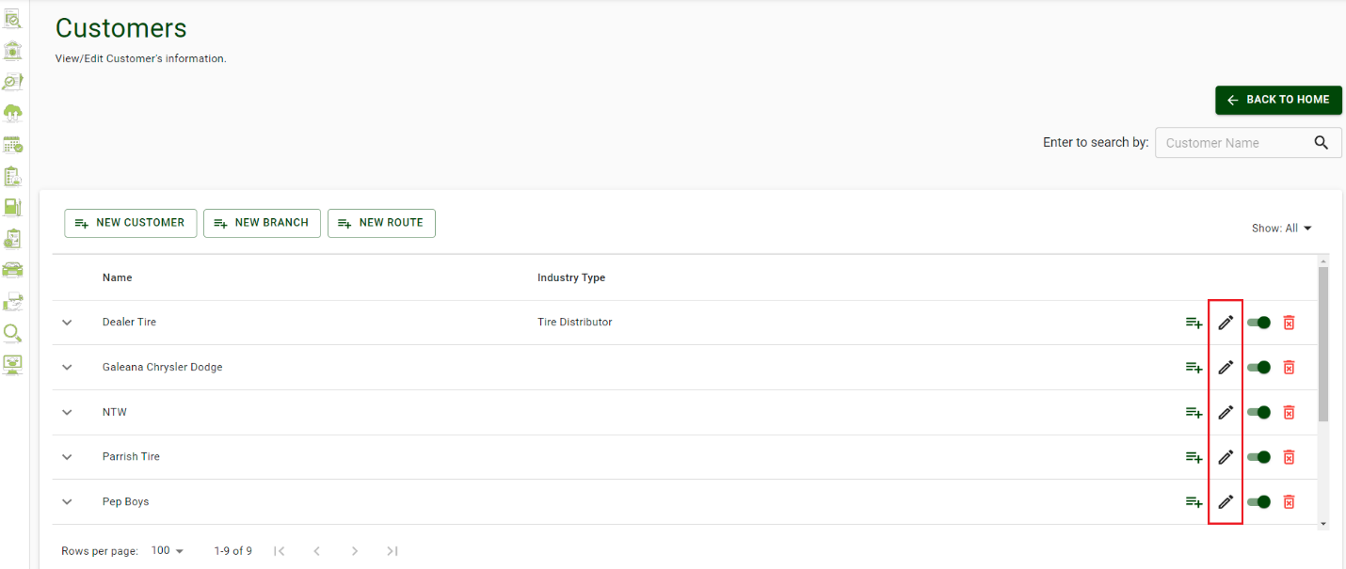
Fig 28. Illustrates the Customer Edit function

- Mark a customer and its branch as active/inactive:
To mark a customer branch as inactive, the Account Administrator must click on the Toggle button present in front of the Customer and/ or Branch to be deactivated.

Note: In actuality, a customer or branch that is present in a base roster will display a pop-up requesting confirmation that the base roster data will also be deactivated.

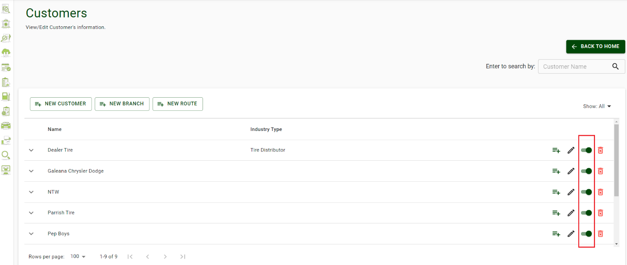
Fig 29. Illustrates the Customer’s active/inactive function

- Delete the customers, branches, routes:
Account Administrators can delete an existing record by clicking on the delete button to the right of each line item.
NOTE: Customers and Branches can be deactivated, however route only be deleted at the customer level. Use the base roster to deactivate a specific route temporarily.

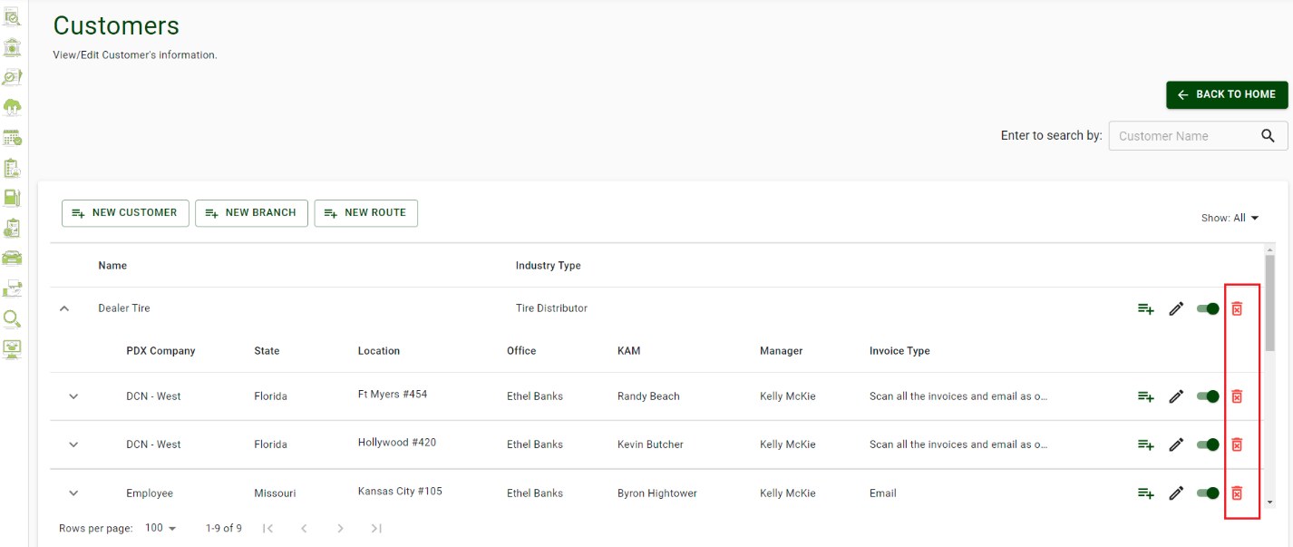
Fig 30. Illustrates the Customer edit route function

- Search a Specific Customer Record using the Search field:
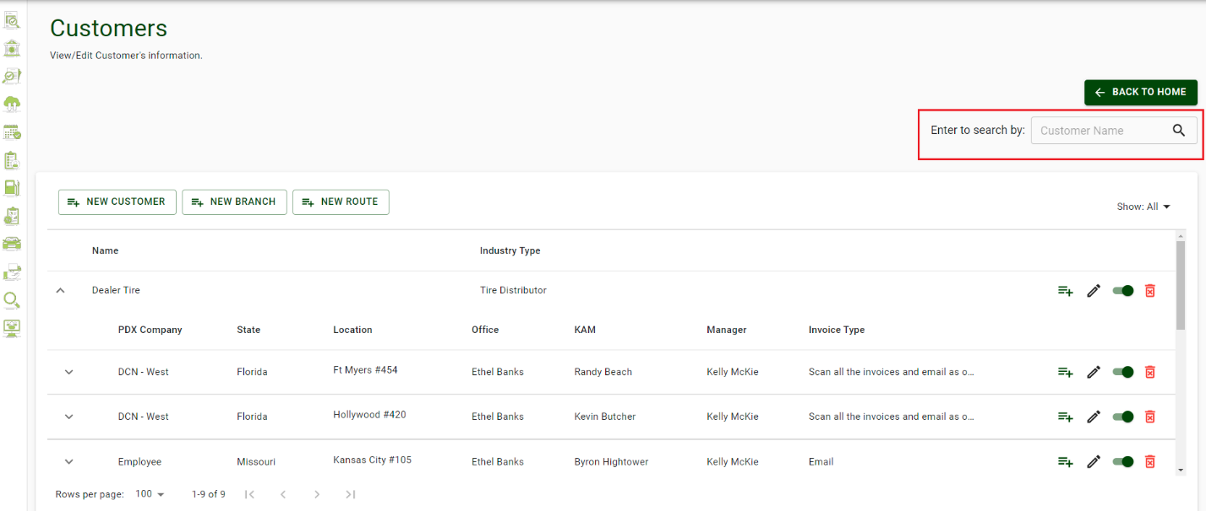
Account Administrators can search a particular customer record by entering the name of the required customer in the search field. Once entered, it will display all the matching records in the grid.
Fig 31. Illustrates the Customer Search function

- View the customer records according to their active/inactive status:
To view the records of Only Active or Only Inactive customers, Account Administrators must:
  - Click on the Drop-Down Menu on the top right side of the grid.
  - Select one of the three options:
    - Only Active: If selected, displays only the active Customers in the grid.
    - Only Inactive: If selected, display only the inactive Customers in the grid.
    - All: If selected, it displays both the active and inactive Customers in the grid.

Lookup
The Lookup section of the PDX Processing System can be used to Add, Edit, and View information. In this section, you can select from Contractor Type, Industry Type, PDX Company, Settlement Company, and Vehicle.
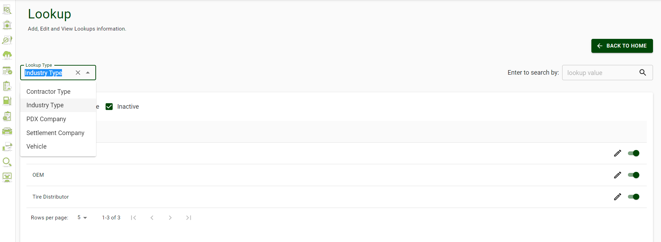
Fig 32. Illustrates the Lookup Screen

Billing & Settlement Review
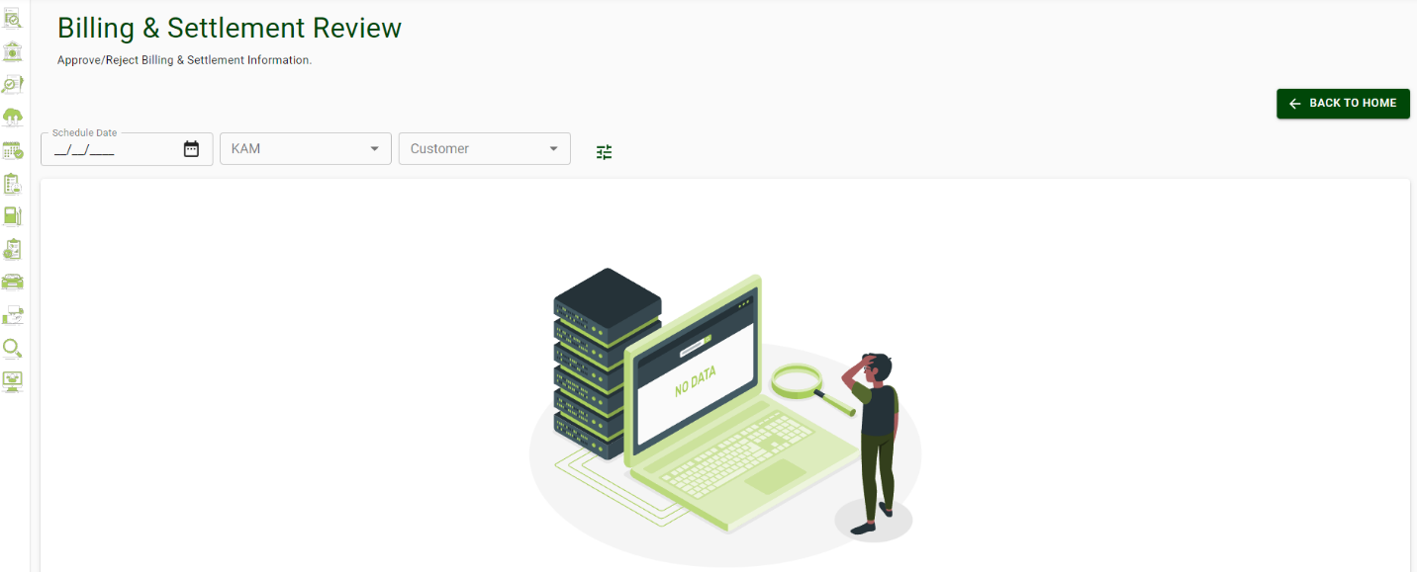
The Billing & Settlement Review section of the PDX Processing System can be used to Approve/Reject Billing and Settlement information.
Fig 33. Illustrates the Billing and Settlement Screen

Note: Records that have been changed by a manager or AA will be sent to Billing and Settlement review for ADMIN or other AA approval.

Fuel Price
The Fuel Price section of PDX Processing System can be used to view/add fuel price schedules. AA can view/update the perspective AAA pricing for Regular and Diesel across the U.S.

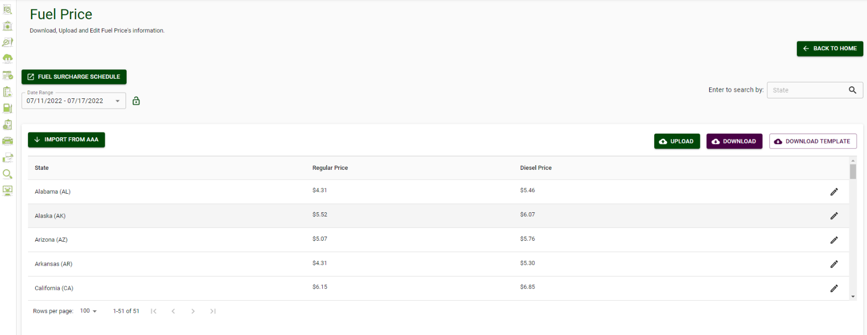
Fig 34. Illustrates the Fuel Price Screen

Part I: AA can refer to the drop-down list to view previous fuel prices for each week

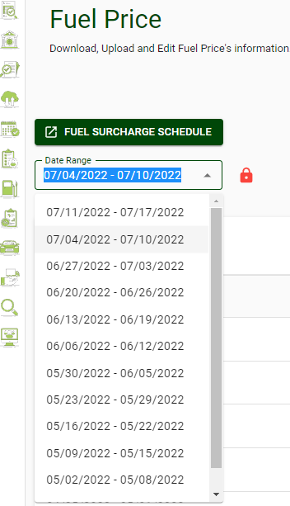

Fig 34. Illustrates the Fuel Surcharge Schedules

Create a new Fuel Surcharge Schedule:

- Click the button labeled ‘Fuel Surcharge Schedule”


- Select a schedule from the drop-down list to view/edit a schedule.
- Click “Add New Schedule” to create a new Fuel Surcharge schedule.

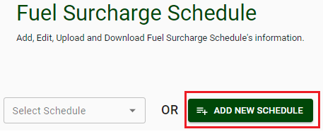

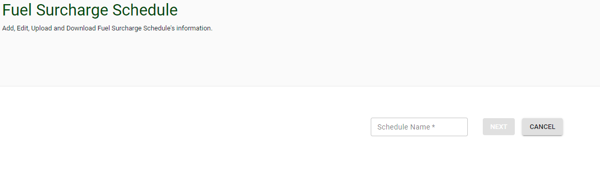
- Enter the name of the schedule into the box (as seen above) and then click next.

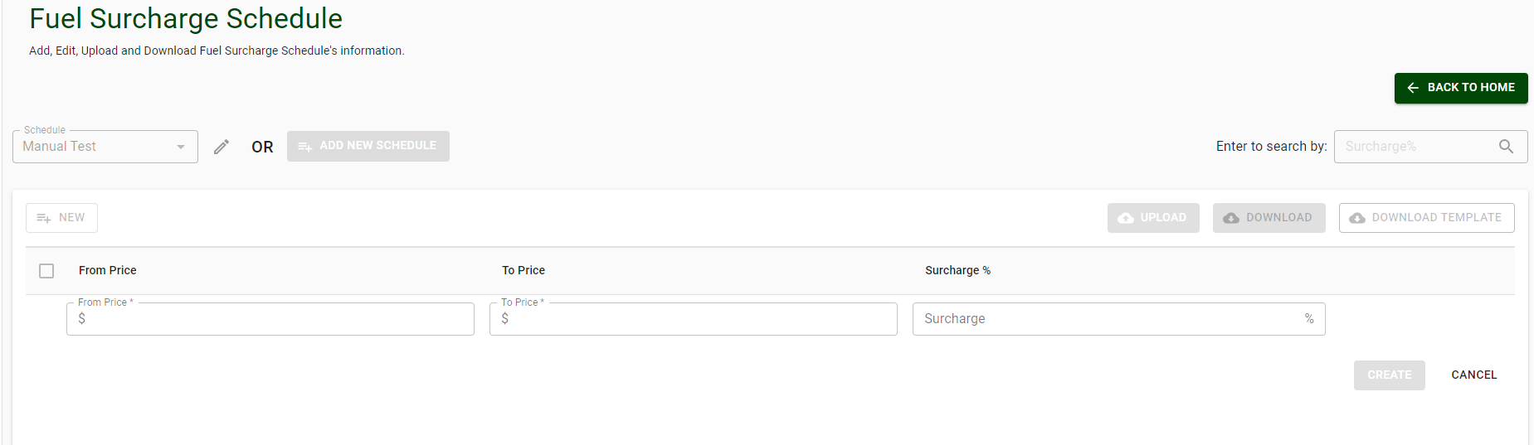
- Once you have given your schedule a name, fill in the corresponding information for the price range as well as the corresponding surcharge.
- Click ‘Create’
- Now you will be able to view your new Fuel Surcharge Schedule within the drop-down.

Further Help
If you are in need of help using the PDX Processing System, please email our customer service team at itsupport@pdxdelivers.com. Alternatively, call 1-610-595-3390

If you would like to learn more about PDX Delivers, please email us at:

www.pdxdelivers.com

